**A**

**PROJECT REPORT**

**ON**

**IPL Win Prediction**

IN

THE PARTIAL FULFILLMENT OF REQUIREMENT FOR THE AWARD OF THE DEGREE

OF

**MASTER OF COMPUTER APPLICATION**

### Under the supervision of: Submitted by:

##### Mr. Sumit Singha Rishabh Agarwal

Assistant Professor **Akash Sen**

Department of Computer Applications **Aman Kumar Gupta**

Asansol Engineering College, Asansol-713305 **Shaibal Patra**

**Raj Kumar Jha**



**DEPARTMENT OF COMPUTER APPLICATIONS**

**ASANSOL ENGINEERING COLLEGE, ASANSOL (AFFILIATED**

**TO MAKAUT UNIVERSITY) WEST BENGAL KOLKATA – 700064**

MCA MAJOR PROJECT

**CANDIDATE’S DECLARATION**

We, “**Rishabh Agarwal**”, “**Akash Sen**”, “**Aman Kumar Gupta**”, “**Shaibal Patra**” and “**Raj Kumar Jha**”, hereby declare that the work presented in the project report entitled “**IPL win Prediction**” submitted to Department of Computer Applications, Asansol Engineering College, affiliated to **Maulana Abul Kalam Azad University of Technology, West Bengal** for the partial fulfillment of the award of degree of “**Master of Computer Application**” is an authentic record of our work carried out during **the MCA 4th Semester 2024,** under the supervision of **Dr. Arnab Chakraborty**, Trainer (as External Guide) and **Mr. Sumit Singha**, Department of Computer Applications, **Asansol Engineering College** (as Internal Guide).

The matter embodied in this project report has not been submitted elsewhere by anybody for the award of any other degree.

###### Group Members:

|  |
| --- |
| **Rishabh Agarwal**  Maulana Abul Kalam Azad University of Technology 10871023036 |
| **Akash Sen**  Maulana Abul Kalam Azad University of Technology 10871023009 |
| **Aman Kumar Gupta**  Maulana Abul Kalam Azad University of Technology 10871023010 |
| **Shaibal Patra**  Maulana Abul Kalam Azad University of Technology 10871023044 |
| **Raj Kumar Jha**  Maulana Abul Kalam Azad University of Technology 10871023035 |

MCA MAJOR PROJECT



**Reference No.: CA-MCA/2025/ Date: …………………….**

**CERTIFICATE**

To whom it may concern

This is to certify that the project titled “**IPL Win Prediction**” is a bonafide work carried out by **Rishabh Agarwal (10871023036)**, **Akash Sen (10871023009)**, **Aman Kumar Gupta (10871023010)**, **Shaibal Patra (10871023044)**, **Raj Kumar Jha (10871023035)** in the partial fulfillment of the awards of the degree of **Master of Computer Application** from Asasnol Engineering College, Asansol, under the supervision of **Mr. Sumit Singha**.

_____________________ ______________________________

**Mr. Sumit Singha Dr. Anup Mukhopadhyay**

Assistant Professor Head of Department

Dept. of Computer Application Dept. of Computer Application

____________________________

**Dr. G.S.Panda**

Principal In-Charge

Asansol Engineering College

MCA MAJOR PROJECT

Contents

|  |
| --- |
|  |
|  |
|  |
| |  |  |  | | --- | --- | --- | | **Sl. No.** | **Topic** | **Page No.** | | 1. | Acknowledgement | 1 | | 2. | System Study | 2-5 | | 3. | Project Objective | 6 | | 4. | Project Scope | 7 | | 5. | Data Description | 8-11 | | 6. | Data Preprocessing | 12-14 | | 7. | Exploratory Data Analysis | 15-20 | | 8. | Model Training | 21-45 | | 9. | Test Data | 46 | | 10. | User Interface Design | 47-50 | | 11. | Codes | 51-74 | | 12. | Future Scope Improvements | 75-76 | | 13. | Conclusion | 77 | | 14. | References | 78 | |  |  |  | |  |  |  | |

Acknowledgement

We would like to thank people who were part of this work in numerous ways. In particular, we wish to thank **Dr. Arnab Chakraborty** (Trainer, External Guide), our project guides for their suggestions and improvements in this project and providing continuous guidance at each and every stage of the project.

Thanks are extended especially to our guide **Ms. Sumit Singha** (Asst. Professor, CA Department, Asansol Engineering College, Asansol and to **Dr. Anup Mukhopadhyay** (HOD, CA Department, Asansol Engineering College). We also thank **Ms. Debika Chatterjee** (Training and Placement Officer, Asansol Engineering College) for her valuable support. We must also be thankful to classmates and friends for their continuous co-operations and help in completing this project.

Last but not the least, We want to express our thanks to our parents and family members for their support at every step of life.

________________________

**Rishabh Agarwal**

________________________

**Akash Sen**

________________________

**Aman Kumar Gupta**

________________________

**Shaibal Patra**

________________________

**Raj Kumar Jha**

**Date: 2nd Year**

**Place: Asansol Dept. of Computer Application**

System Study

The **System Study** forms a foundational part of this project report, aiming to evaluate the problem domain, examine existing alternatives, and present a thorough analysis of the proposed IPL Win Predictor model. It includes understanding user requirements, analyzing feasibility, and designing the architecture to meet the outlined objectives.

**1. Problem Identification**

Cricket, particularly the Indian Premier League (IPL), is a highly dynamic and unpredictable sport. Match outcomes can change dramatically within a few deliveries, making it difficult for viewers, analysts, and even professional commentators to accurately assess which team has the upper hand during a live match.

Traditionally, match predictions have relied on expert opinions or simplistic heuristics based on runs required, balls remaining, and wickets lost. However, such approaches:

* Fail to quantify win/loss probabilities.
* Do not adapt to real-time inputs.
* Lack data-driven insights.

There was a need for an intelligent system capable of leveraging historical match data and real-time statistics to predict the probability of a team winning a game. This gap motivated the development of a **machine learning-based IPL Win Predictor**.

**2. Existing Systems**

A few platforms such as CricBuzz, ESPNcricinfo, and official IPL broadcasters provide live match coverage with basic win probability meters. However:

* These systems are typically proprietary and lack transparency in how predictions are made.
* They do not allow user interaction or scenario simulation.
* They are not designed as open platforms for experimentation, learning, or community-based analysis.

There was a lack of an **open-source**, **interactive**, and **data-driven** application where users could enter live match data and receive win/loss probabilities through a visually intuitive interface.

**3. Proposed System**

The proposed system addresses these limitations through a machine learning-based web application that provides win probability predictions during an IPL match. Key highlights include:

**a. User Input Interface**

Users can input:

* Batting and bowling teams
* Match city (venue)
* Target score
* Current score
* Overs completed
* Wickets fallen

**b. Data Processing**

The system computes:

* Runs left
* Balls remaining
* Current run rate (CRR)
* Required run rate (RRR)
* Remaining wickets

**c. Machine Learning Model**

The backend model is trained on historical IPL data using several machine learning algorithms:

* **Logistic Regression**: For linear decision boundaries and baseline benchmarking.
* **Random Forest**: For ensemble learning with decision trees.
* **AdaBoost & XGB**: For improving accuracy via boosting.
* **SVM**: For optimized decision boundaries in high-dimensional space.

The final model is selected based on performance metrics such as **accuracy**, **F1-score**, and **ROC-AUC**.

**d. Interactive Front-End**

A web application is built using:

* **Streamlit** for UI components.
* **Plotly** for dynamic visualizations such as pie charts.
* **Pickle** for model serialization.

The app presents users with the predicted win and loss probabilities along with real-time visual feedback.

**4. Feasibility Study**

**a. Technical Feasibility**

* Python is used as the primary language with supporting libraries like scikit-learn, pandas, plotly, and streamlit.
* The model is trained and deployed using open-source tools, making the system highly feasible for development and maintenance.

**b. Economic Feasibility**

* No proprietary software or commercial tools are used.
* Deployment on platforms like Streamlit Cloud or localhost ensures zero hosting cost in development and early deployment phases.

**c. Operational Feasibility**

* The system is highly user-friendly and requires no technical expertise from end-users.
* Visual elements and real-time updates make it accessible for cricket fans and casual users alike.

**d. Schedule Feasibility**

The system was developed in structured phases:

* Data collection and preprocessing.
* Model training and evaluation.
* UI development and integration.
* Testing and deployment.

All stages were completed within a reasonable timeline using agile development practices.

**5. System Architecture Overview**

The architecture of the IPL Win Predictor system follows a modular and scalable structure:

**a. Data Layer**

* Cleaned and structured historical IPL match data.
* Features include team names, venue, score details, overs, wickets, and match outcomes.

**b. Model Layer**

* Trained machine learning model (pipe.pkl) created using a pipeline approach for preprocessing and prediction.
* Models were evaluated for optimal performance and interpretability.

**c. Logic Layer**

* Computes derived metrics: runs left, balls left, CRR, RRR, and wickets remaining.
* Packages inputs into a format compatible with the model.

**d. Presentation Layer**

* Built using Streamlit for input forms and interactive charts.
* Displays prediction results and win probabilities in textual and graphical formats.

**6. Benefits of the Proposed System**

* **Real-Time Insights**: Users receive instant feedback on win/loss chances.
* **Interactive Learning Tool**: Useful for understanding match dynamics and model behavior.
* **Open and Extendable**: The system can be easily extended with more data or new models.
* **Engaging Visuals**: Enhances user experience through charts and stats.

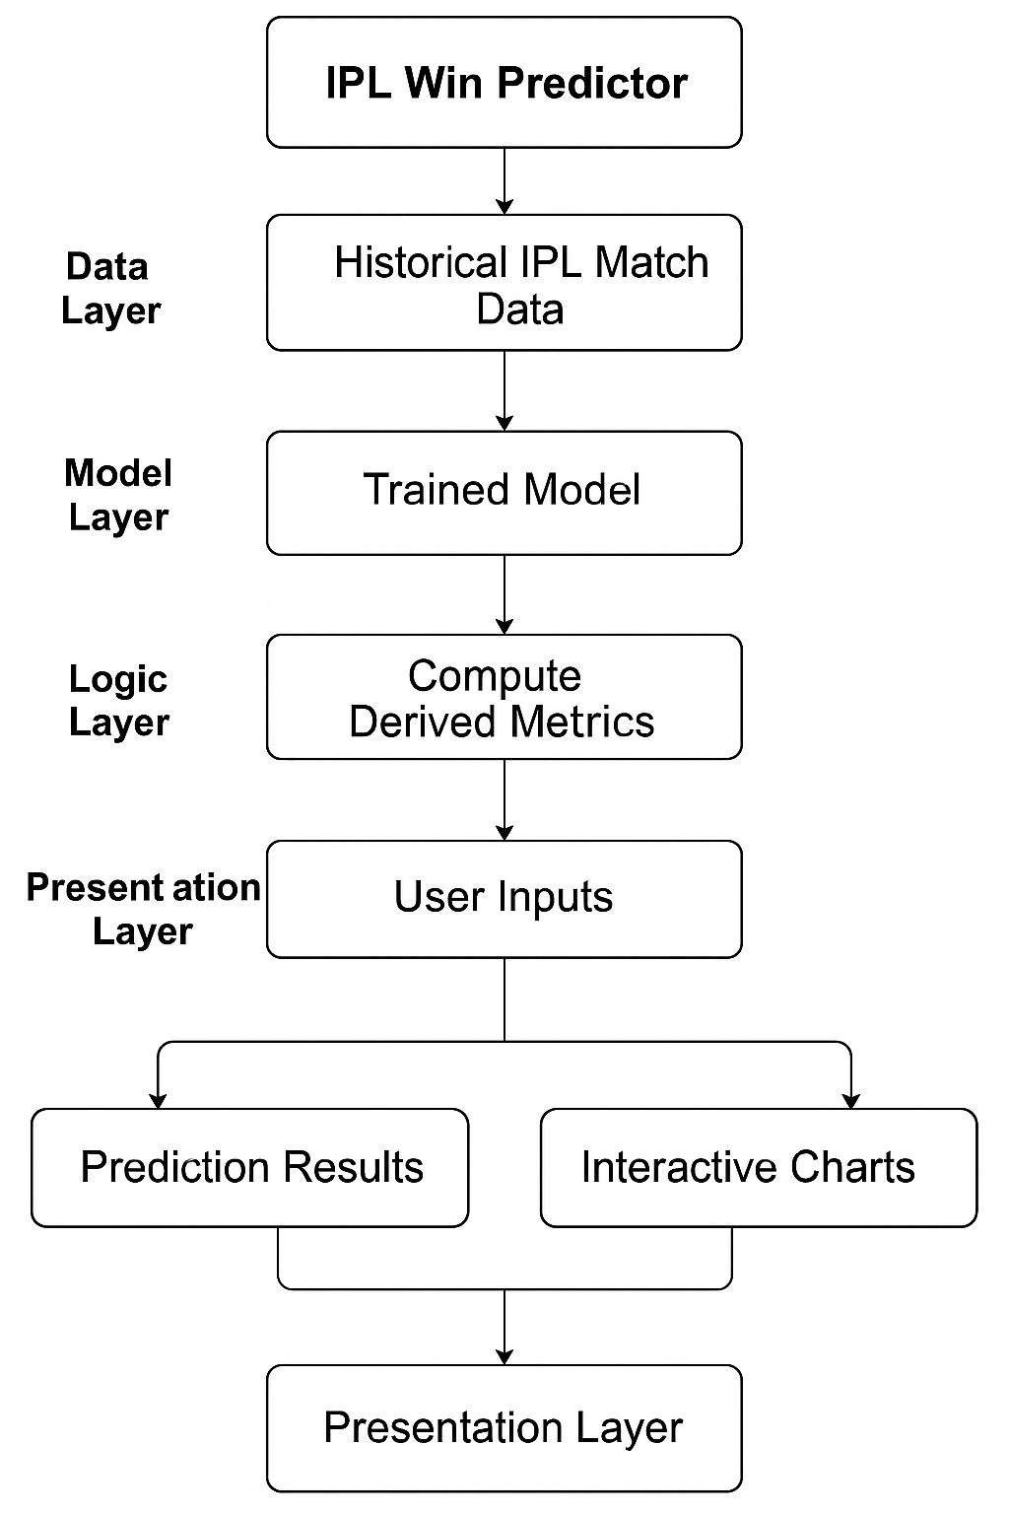

Project Objective

The main objective of this project is to build a data-driven predictive model that forecasts the probable winner of an IPL (Indian Premier League) match based on historical match data and performance metrics. The project leverages data preprocessing, feature engineering, and machine learning to model real-world scenarios for T20 cricket matches.

Key Goals:

* **Data Collection & Cleaning:**
  + Load and process two key datasets: matches.csv and deliveries.csv.
  + Standardize team names to ensure consistency (e.g., "Delhi Daredevils" → "Delhi

Capitals").

* + Filter out irrelevant or outdated teams to focus only on current franchises.
* **Feature Engineering:**
  + Calculate first-inning scores using ball-by-ball data.
  + Merge score data with match-level data to derive useful features like total first-inning runs.
* **Visualization & Insights:**
  + Use libraries like Matplotlib and Seaborn for EDA (Exploratory Data Analysis).
  + Generate insights about team performance trends and scoring behavior over the years.
* **Predictive Modeling:**
  + Use historical performance metrics such as runs scored, toss decisions, and venue to predict outcomes.
  + Apply classification models (likely Logistic Regression or Decision Tree based on standard practice) to predict win probability for chasing teams.
* **Real-time Input:**
  + Enable users to input match scenarios (like team names, target score, overs, etc.) and get win probabilities as output.

Outcome:

* A functional prediction system that estimates the likelihood of a team winning an IPL match, particularly while chasing a target.
* A deeper understanding of how various factors like toss result, venue, and first-inning score affect match outcomes.

Project Scope

This project is scoped to analyze historical IPL data to build a predictive model that estimates match outcomes under certain input scenarios. It covers a full data science pipeline from raw data to deployment-ready insights.

In Scope:

* **Data Sources:**
  + Match-level data (matches.csv)
  + Ball-by-ball data (deliveries.csv)
  + Filtering based on current IPL teams (8 franchises as of recent seasons).
* **Data Preprocessing:**
  + Handling null values, renaming outdated teams, dropping irrelevant columns.
  + Merging datasets on match ID to link innings scores with match metadata.
* **Feature Selection:**
  + Batting team and bowling team
  + Venue of the match
  + First-inning total runs
  + Current Run Rate
  + Required Run Rate
  + Wickets Fallen
* **Modeling & Evaluation:**
  + Building a classification model (Logistic Regression, Random Forest, AdaBoost, XGBoost, SVM) to predict match results.
  + Training the model using features like team names, runs, overs, and wickets.
  + Testing the model against known outcomes to validate accuracy.
* **Visualization:**
  + Trends in scoring
  + Team-wise win ratios
  + Impact of toss and venue on results
* **Application Use Case:**
  + Ideal for sports analysts, IPL fans, or betting enthusiasts looking for data-backed predictions.

Out of Scope:

* Player-specific performance prediction (e.g., batsman scoring prediction).
* Real-time score prediction during ongoing matches.
* Live API integration or deployment as a web/mobile app.

Data Description

Source of the data:

Kaggle. The datasets used are adapted and filtered versions of the original IPL datasets available on Kaggle.

Dataset 1: matches.csv

* **Rows**: ~756
* **Columns**: 18

|  |  |  |  |
| --- | --- | --- | --- |
| **Attribute**  **Name** | **Type** | **Description** | **Target**  **Attribute** |
| id | Non-  categorical | Unique match identifier | No |
| season | Categorical | IPL season/year | No |
| city | Categorical | City where the match was played | No |
| date | Non-  categorical | Date of the match | No |
| team1 | Categorical | First team | No |
| team2 | Categorical | Second team | No |
| toss_winner | Categorical | Team that won the toss | No |
| toss_decision | Categorical | Decision taken after winning the toss  (bat/field) | No |
| result | Categorical | Result type (normal/tie/no result) | No |
| winner | Categorical | Match winner | Yes |

Table 1: Data Description (matches.csv)

Dataset 2: deliveries.csv

* **Rows**: ~1,798,000
* **Columns**: 21

|  |  |  |  |  |
| --- | --- | --- | --- | --- |
| **Columns** | **Attribute Name** | **Type** | **Description** | **Target**  **Attribute** |
| match_id | match_id | Non-  categorical | Match identifier | No |
| inning | inning | Categorical | 1st or 2nd innings | No |
| over | over | Non-  categorical | Over number | No |
| ball | ball | Non-  categorical | Ball number within an over | No |
| batsman | batsman | Categorical | Name of the batsman on  strike | No |
| bowler | bowler | Categorical | Name of the bowler | No |
| total_runs | total_runs | Non-  categorical | Runs scored off the delivery  including extras | No |
| player_dismissed | player_dismissed | Categorical | Name of the player  dismissed | No |

Table 2: Data Description (deliveries.csv)

**Dataset 3:** final_dataset.csv

* **Rows:** ~760
* **Columns**: 12

|  |  |  |  |  |
| --- | --- | --- | --- | --- |
| **Columns** | **Attribute Name** | **Type** | **Description** | **Target**  **Attribute** |
| batting_team | batting_team | Categorical | Team currently batting | No |
| bowling_team | bowling_team | Categorical | Opponent team bowling | No |
| city | city | Categorical | City where the match is  being played | No |
| runs_left | runs_left | Non-  categorical | Runs left to win | No |
| balls_left | balls_left | Non-  categorical | Balls remaining | No |
| wickets_left | wickets_left | Non-  categorical | Wickets remaining | No |
| total_runs_x | total_runs_x | Non-  categorical | Target score | No |
| current_run_rate | current_run_rate | Non-  categorical | Current run rate | No |
| required_run_rate | required_run_rate | Non-  categorical | Required run rate | No |
| result | result | Categorical | Win (1) or loss (0) | Yes |

Table 3: Data Description (final_dataset.csv)

Now we will pre-process the data. The methodology followed is given below:

* Checking for null values.
  + If null values are present, we will fill them or drop the row containing the null value based on the dataset.
* Check for duplicate values.
  + If duplicate values are present, we will remove them.

Data Preprocessing

This section prepares the raw IPL data into a structured form usable for modeling.

**1.1 Loading Datasets**

* matches.csv and deliveries.csv are loaded using pandas.read_csv().
* Shapes of dataframes are displayed to understand their size.

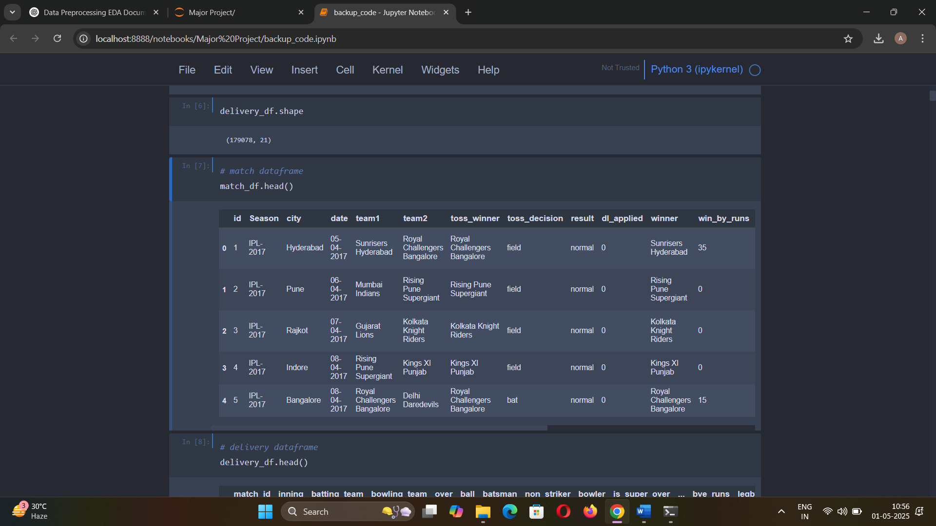

**1.2 Inspecting DataFrames**

* .head(), .info(), and .describe() are used.
* Focus is on match-level and ball-level data.

**1.3 Calculating First Innings Totals**

* delivery_df is grouped by match_id and inning to compute total_runs.
* Only inning == 1 is retained as it represents the target score.

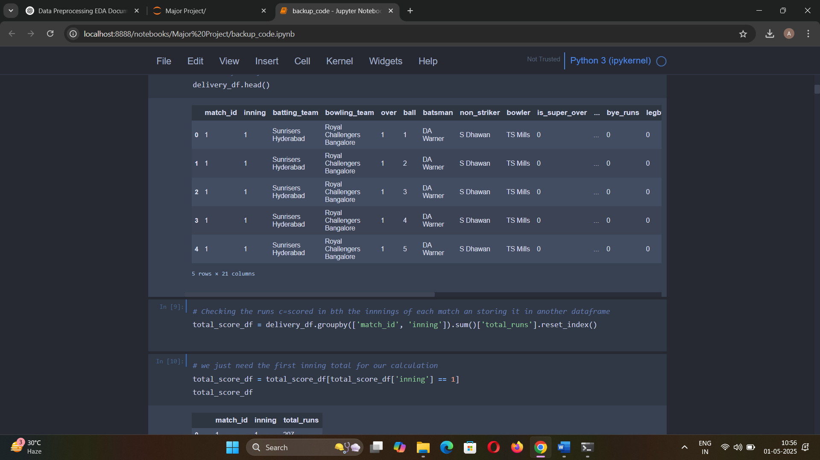

**1.4 Merging with Match Data**

* match_df is merged with total_score_df using match_id.
* Columns like team1, team2, and total_runs are retained.

**1.5 Team Name Standardization**

* Legacy team names (Kings XI Punjab, Delhi Daredevils) are replaced with current ones using str.replace().
* Only currently active teams are retained using a whitelist.

merge['team1'] = merge['team1'].str.replace('Delhi Daredevils', 'Delhi Capitals')

merge['team2'] = merge['team2'].str.replace('Delhi Daredevils', 'Delhi Capitals')

merge['team1'] = merge['team1'].str.replace('Deccan Chargers', 'Sunrisers Hyderabad')

merge['team2'] = merge['team2'].str.replace('Deccan Chargers', 'Sunrisers Hyderabad')

merge['team1'] = merge['team1'].str.replace('Kings XI Punjab', 'Punjab Kings')

merge['team2'] = merge['team2'].str.replace('Kings XI Punjab', 'Punjab Kings')

**1.6 Filtering for Valid Matches**

* DLS-affected matches (dl_applied == 1) are dropped.
* This ensures uniformity in target-setting logic.

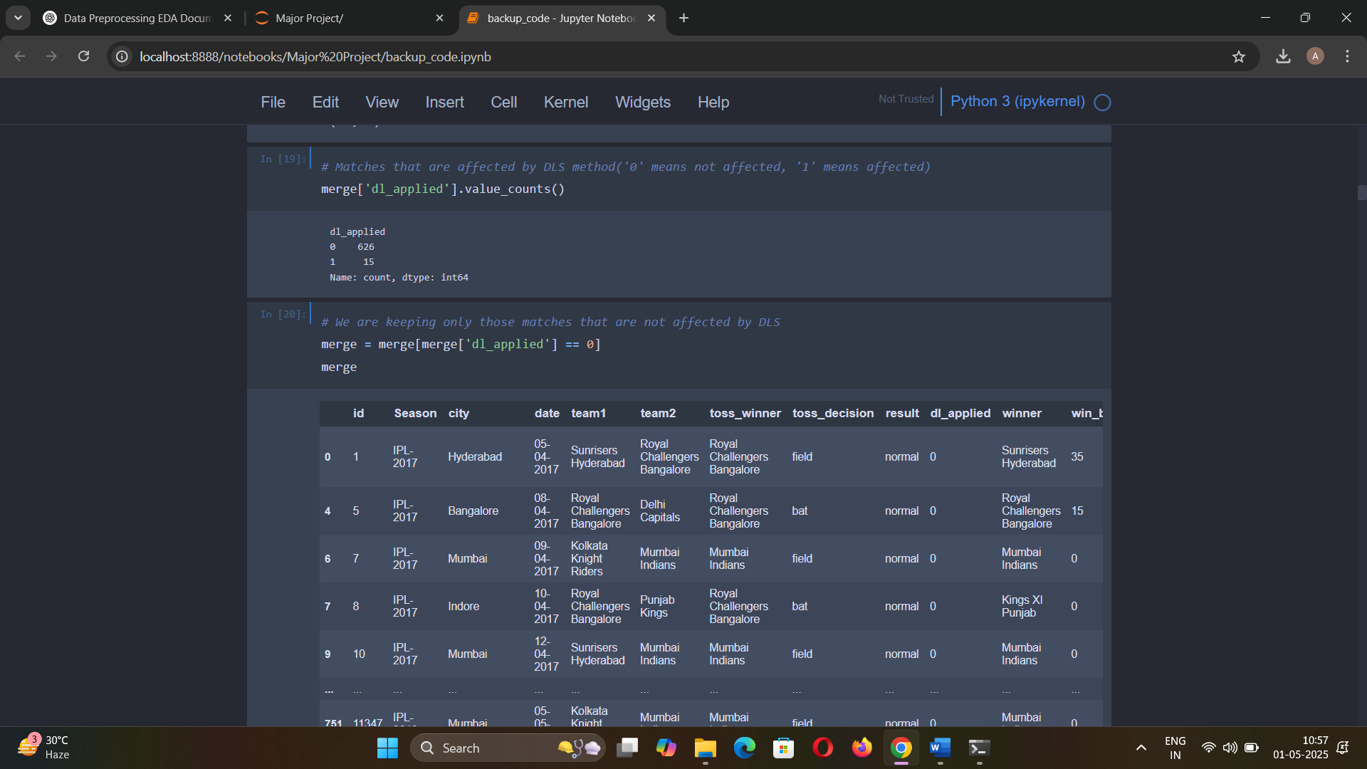

**1.7 Merging Ball-by-Ball Data**

* merge is again joined with delivery_df on match_id.
* Only 2nd innings deliveries are retained (inning == 2) to analyze chases.

**1.8 Handling Missing Values**

* city is filled with mode.
* winner is filled with "No Result" where applicable.

merge_df = merge_df.assign(

    city = merge_df['city'].fillna(merge_df['city'].mode()[0]),

    winner = merge_df['winner'].fillna('No Result')

)

**1.9 Final Feature Cleanup**

* Final features prepared: batting_team, bowling_team, city, total_runs_x, winner, etc.
* String columns are stripped of extra spaces and checked for consistent casing.

final_df = merge_df[['batting_team','bowling_team','city','runs_left','balls_left','wickets','total_runs_x','crr','rrr','result']]

final_df

# Exploratory Data Analysis (EDA)

Exploratory Data Analysis (EDA) is a crucial phase in our fake news detection project, involving the initial investigation of the dataset to uncover patterns, spot anomalies, test hypotheses, and check assumptions through summary statistics and graphical representations. EDA helps us understand the underlying structure of the data, identify relationships between variables, and guide further preprocessing and modelling steps.

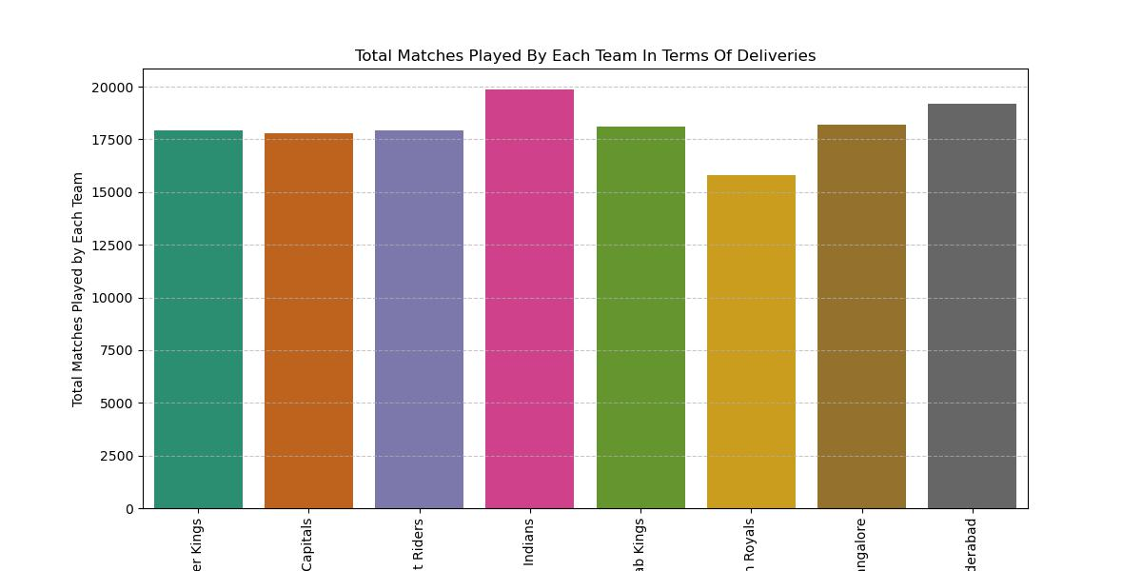

**Fig 1:** *The above graph showing Total matches played by each team in terms of deliveries*

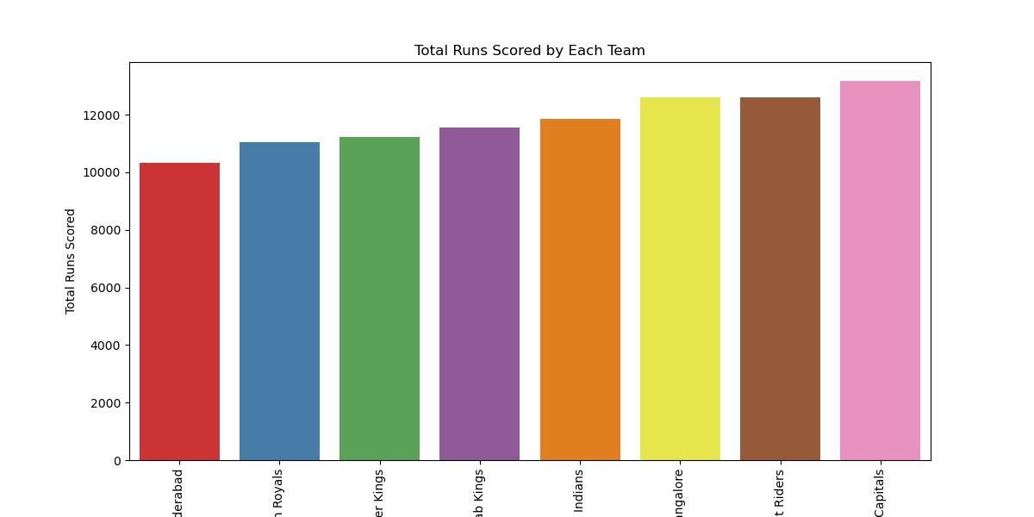

***Fig 2:*** *Delhi Capitals scored the highest number of runs over the years up to 2019 and Sunrisers Hyderabad scored the less amount of runs compared to other teams.*

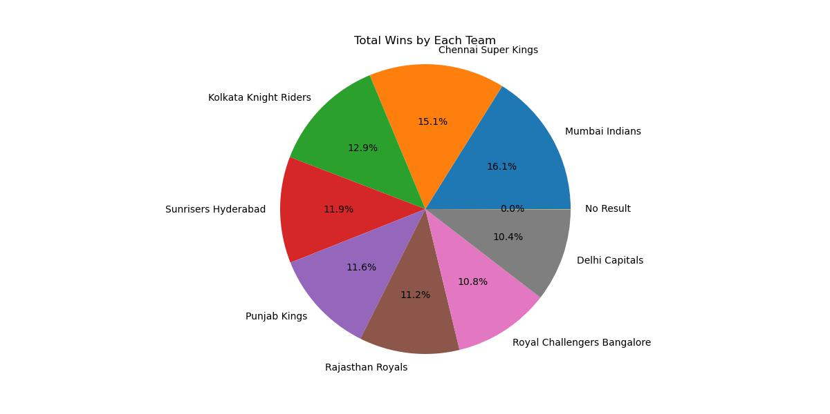

***Fig 3:***

*Pie chart showcasing win percentage by each team*

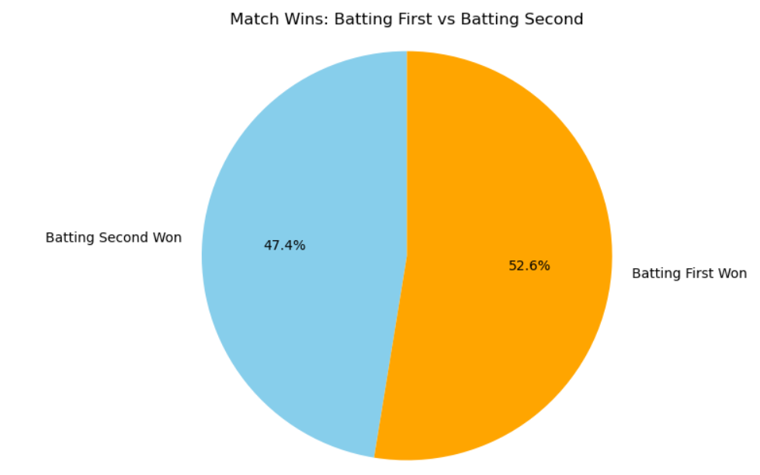

***Fig 4:***

*Pie chart showcasing winning percentage of teams batting first vs batting second*

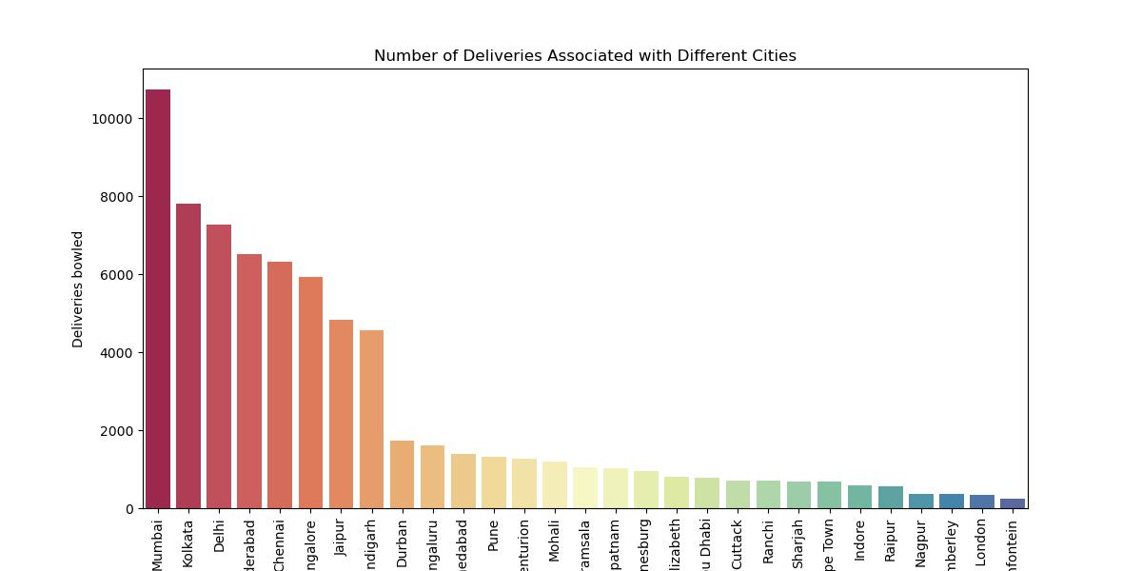

***Fig:5***

*Diagram showcasing Number of Deliveries Associated with Different Cities*

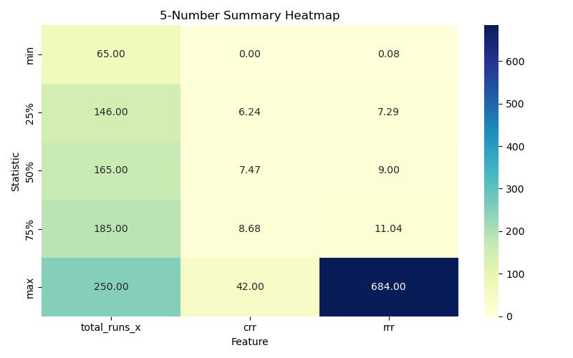

***Fig 6:*** *Heatmap of current run rate, net run rate and total runs*

In the context of our ‘IPL win predictor’ project, the heatmap can be used to visualize the relationships between different features in your dataset. For example, you might see that certain features are highly correlated with each other, while others are not. This information can be used to select features for our model, as well as to understand how different features interact with each other.

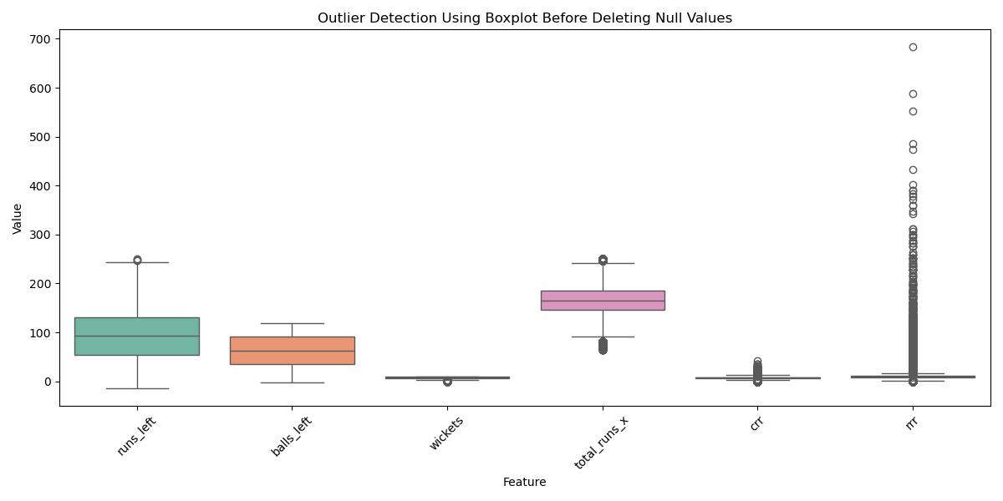

***Fig 7:***

*Boxplot showcasing the outliers*

Description

**Figure 1: Total Matches Played by Each Team (via Deliveries)**

* This bar chart visualizes the total number of deliveries faced by each team, serving as a proxy for the number of matches played. It helps understand team participation and consistency across seasons.

**Figure 2: Total Runs Scored by Each Team**

* This graph compares cumulative runs scored by teams across all IPL seasons up to 2019. It highlights Delhi Capitals as the highest-scoring team and Sunrisers Hyderabad with the lowest aggregate runs, reflecting overall batting performance**.**

**Figure 3: Win Percentage by Each Team (Pie Chart)**

* A pie chart representing the proportion of matches won by each team. It provides a quick visual overview of team dominance and competitive balance in the IPL.

**Figure 4: Win Percentage – Batting First vs Batting Second**

* This pie chart contrasts win ratios of teams batting first versus chasing. It helps assess whether chasing or defending totals offers a higher chance of winning in IPL matches.

**Figure 5: Number of Deliveries Associated with Each City**

* A bar graph showing the number of deliveries bowled in each city, which indicates how frequently each city has hosted IPL matches. Cities with higher counts are primary venues.

**Figure 6: Heatmap of Current Run Rate, Net Run Rate & Total Runs**

* A correlation heatmap that shows the relationships among continuous features such as current run rate, required run rate, and total runs. This helps in identifying multicollinearity and selecting key predictors for modeling.

**Figure 7: Boxplot Before Data Cleaning**

* This boxplot displays feature distributions and highlights outliers before handling null values and correcting negative entries. It visually justifies the need for preprocessing.
* **Outlier:** An outlier is a data point that significantly differs from other observations in a dataset. It lies far outside the overall pattern of the distribution and can be unusually high or low compared to the rest of the data.

Therefore from the EDA we can determine that Teams batting first have a higher win percentage compared to teams batting second(chasing).

This insight is supported by the pie chart in **Figure 4**, which compares win percentages based on batting order. It suggests that **setting a target is often more successful in IPL matches**. This finding can be **used as a feature in our model** (e.g., "batting first" flag), and it supports the intuition that **toss decision (bat or field)** may significantly influence match outcome

# Model Building

### Step-by-Step Elaboration on Model Training:

1. **Data Preparation:**

Extracting Features and Labels

* + **Explanation:** The features (X) consist of the cleaned text data, and the labels (y) represent the class of results (win or loss). This separation is essential for training and evaluating the machine learning model.

### Splitting the Data:

* + **Explanation:** The dataset is split into training and testing sets using an 80-20 split. The random_state ensures reproducibility. This step is crucial for evaluating the model's performance on unseen data.

### Division of Input Features :

**Explanation:** The input features(Batting Team, Bowling Team, City, runs_left, balls_left, wickets, total_runs_x, current run rate, required run rate are divided into two types i.e**. Categorical** and **Numeric** features.

### Column Transformation:

* + **Explanation:** **ColumnTransformer** class from the sklearn.compose module. ColumnTransformer is used to apply different preprocessing steps to different columns of a dataset, which is useful when you have a mix of numerical and categorical data that requires different transformations. **OneHotEncoder** is used to convert categorical variables into binary vectors (dummy variables).

### Standardizing and Normalizing Input Features:

**Explanation:** We have used **StandardScaler** that scales numerical features. **StandardScaler** standardizes features by removing the mean and scaling to unit variance.

### Pipeline Creation:

* + **Explanation:** We have used **Pipeline** for the following reasons:
    - **Cleaner code**: You don’t have to manually transform and then fit the model.
    - **Less error-prone**: Ensures that the same transformations are always applied.

In our IPL Win Prediction project, the data preparation and model training steps involve extracting and cleaning noisy data, splitting it, and transforming it into numerical data using a ColumnTransformer. By standardizing the numerical features, we ensure they are suitable for machine learning algorithms. These steps form the foundation for building a robust and accurate IPL Win Prediction Model.

***Below are the ML Algorithms we have implemented in our project:***

## Logistic Regression:

* + **Introduction: Logistic Regression** is a type of supervised learning algorithm used for classification tasks. Despite its name containing **"regression"** it is actually used for classification problems. It is called logistic regression because it employs the logistic function to model the probability of a binary outcome given a set of independent variables.
  + Working Principle:

**Model Representation:** In logistic regression, the output (dependent variable) is a binary value, typically encoded as 0 or 1. Given a set of input features (independent variables), LR models the probability that a given input belongs to a particular class.

**Logistic Function (Sigmoid):** The logistic function is a key component of logistic regression. It maps any real-valued number into a range of values between 0 and 1, making it suitable for modelling probabilities.

**Sigmoid Function:**





**Decision Boundary:** The decision boundary separates the classes in the feature space. In logistic regression with two classes, this boundary is a line. For more than two classes, it becomes a hyperplane.

* + Learning/Training Process:

**Cost Function (Log Loss):** Logistic regression uses a cost function called log loss (or cross-entropy loss) to measure its performance. The goal is to minimise this cost function.

Log Loss Function:





**Gradient Descent:** To minimise the cost function, logistic regression typically uses optimization algorithms like gradient descent. The gradient descent algorithm adjusts the parameters 𝜃 iteratively to reach the optimal values that minimise the cost function.

In summary, Logistic Regression is a fundamental and widely used classification algorithm due to its simplicity, interpretability, and effectiveness for linearly separable data. However, it's important to consider its assumptions and limitations when applying it to real world scenarios.

**The Way we have implemented in our Project:**

Importing Necessary Libraries:

from sklearn.linear_model import LogisticRegression

**from sklearn.metrics import accuracy_score, classification_report, confusion_matrix**

**from sklearn.pipeline import Pipeline**

This imports the LogisticRegression class from sklearn's linear_model module, as well as various evaluation metrics from the metrics module.

Instantiate the Logistic Regression Model in a pipeline:

**log_pipe = Pipeline([**

**('preprocessor', preprocessor),**

**('classifier', LogisticRegression())**

**])**

This creates an instance of the LogisticRegression class.

**Training the Model:**

**log_pipe.fit(X_train, y_train)**

This trains the logistic regression model on the training data, where X_train represents the input features (presumably preprocessed and transformed into numerical vectors) and y_train represents the corresponding target labels.

**Making Predictions:**

y_pred_log = log_pipe.predict(X_test)

Here, predict method computes probabilities of the classes.Then, we convert these probabilities into binary predictions by thresholding at 0.5.

**Model Evaluation:**

**print("Random Forest Accuracy:", accuracy_score(y_test, y_pred_random))**

**print("\nClassification Report:\n", classification_report(y_test, y_pred_random))**

**print("\nConfusion Matrix:\n", confusion_matrix(y_test, y_pred_random))**

Here, we evaluate the model's performance using various metrics like accuracy and make the classification report as well as confusion matrix based on the results.

Results:

**Logistic Regression Accuracy: 0.8042258399722896**

**Classification Report:**

**precision recall f1-score support**

**0 0.80 0.78 0.79 6759**

**1 0.81 0.82 0.82 7676**

**accuracy 0.80 14435**

**macro avg 0.80 0.80 0.80 14435**

**weighted av 0.80 0.80 0.80 14435**

**Confusion Matrix:**

**[[5285 1474]**

**[1352 6324]]**

Now we created a confusion matrix to view the actual and predicted test results. Given below is the confusion matrix:

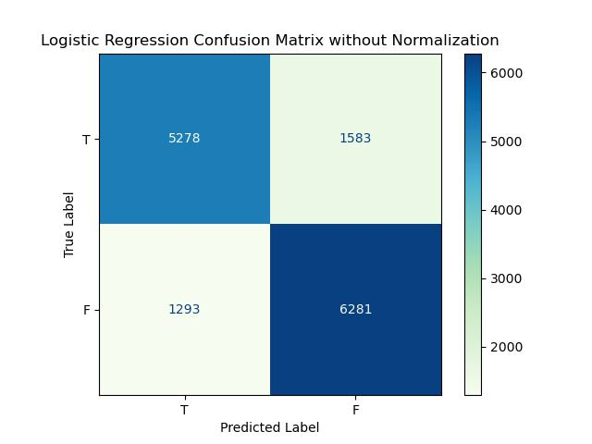

**Fig 10:** *confusion matrix*

So, we have computed that

✔ True Positives (**TP**) = 5278

✔ False Negatives (**FN**) = 1293

✔ False Positives (**FP**) = 1583

✔ True Negatives (**TN**) = 6281

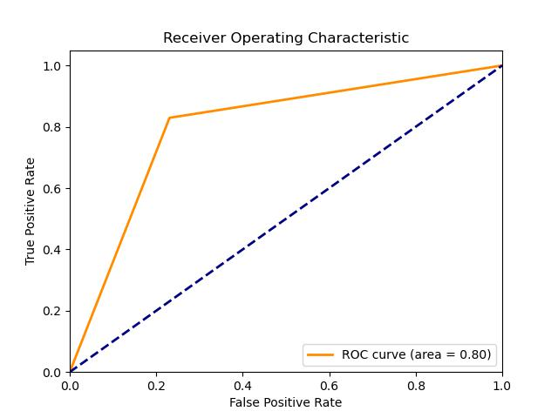

**Fig 11:** *ROC-AUC of logistic regression*

Now we will be preparing the classification report of our Logistic Regression Classifier model.

|  |  |  |  |  |  |
| --- | --- | --- | --- | --- | --- |
| **Classification Report of Logistic Regression model** | | | | | |
| **Accuracy** | | | 0.804 | | |
|  | **precision** | **recall** | | **f1- score** | **support** |
| **0** | 0.80 | 0.77 | | 0.79 | 6861 |
| **1** | 0.80 | 0.83 | | 0.81 | 7574 |

**Table 22:** *classification report*

## Random Forest Classifier:

* + **Introduction:** Random Forest is an ensemble machine learning algorithm that builds multiple decision trees and merges their predictions to achieve more accurate and stable results. It is particularly effective for classification problems with structured tabular data — such as predicting the outcome of an IPL match based on game statistics. In this project, we use the Random Forest Classifier to estimate the winning probability of a team based on features like runs left, wickets, current run rate (CRR), required run rate (RRR), and other match-related metrics.
  + Working Principle:

The Random Forest Classifier operates using the following principle:

1. It creates **multiple decision trees** during training time using random subsets of the data and features.
2. Each tree gives a prediction (i.e., which team will win).
3. The **majority vote** (in classification tasks) from all the trees becomes the final prediction.

* **Key techniques used:**
* **Bootstrap Aggregation (Bagging)**: Random subsets of the training data are sampled with replacement.
* **Feature Randomness**: A random subset of features is used at each split, helping decorrelate the trees and reduce overfitting.
* **Model Representation:** A Random Forest is not represented by a single formula but by an ensemble of decision trees. Each decision tree is structured as a set of nodes:
* **Root Node**: Represents the first feature to split on.
* **Internal Nodes**: Each makes a decision based on a feature's value.
* **Leaf Nodes**: Represent the final prediction.

For an IPL Win Predictor, each tree may learn patterns such as:

* "If runs_left is low and wickets are high, then team likely wins."
* "If RRR is very high and only 3 wickets left, then team likely loses."
* **Splitting Criteria:** Each decision tree in the forest uses a **splitting criterion** to decide how to split data at each node. For classification tasks, the most common criteria are:

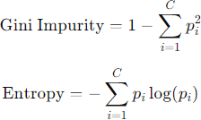

The goal is to split the data such that the child nodes are as "pure" as possible — meaning they contain mostly samples of one class (e.g., win or lose).

### Evaluation

To evaluate the performance of the Random Forest Classifier for predicting match outcomes, we used the following metrics:

1. **Accuracy**: The ratio of correct predictions to total predictions.
2. **Confusion Matrix**: Gives a breakdown of true positives, false positives, true negatives, and false negatives.
3. **Precision, Recall, and F1 Score**: These give more insight, especially in the case of imbalanced data.
4. **ROC Curve & AUC**: Helps visualize model performance across different classification thresholds.

**The Way we have implemented in our Project:**

**Importing Necessary Libraries:**

from sklearn.ensemble import RandomForestClassifier

from sklearn.metrics import accuracy_score, classification_report, confusion_matrix

from sklearn.pipeline import Pipeline

This imports the Random Forest Classifier class from sklearn's ensemble module, as well as various evaluation metrics from the metrics module.

**Instantiate the Decision Tree Model:**

random_pipe = Pipeline(steps=[

('step1',preprocessor),

('step2',RandomForestClassifier())

])

This creates an instance of the RandomForestClassifier class within the pipeline named as random_pipe.

**Training the Model:**

random_pipe.fit(X_train,y_train)

This trains the random forest model on the training data, where X_train represents the input features (preprocessed and transformed into numerical vectors) and y_train represents the corresponding target labels.

**Making Predictions:**

y_pred_random = random_pipe.predict(X_test)

Here, the predict() method is used to generate predictions on the test data.

**Model Evaluation:**

print("Random Forest Accuracy:", accuracy_score(y_test, y_pred_random))

print("\nClassification Report:\n", classification_report(y_test, y_pred_random))

print("\nConfusion Matrix:\n", confusion_matrix(y_test, y_pred_random))

Here, we evaluate the model's performance using various metrics like accuracy, and generate the classification report and confusion matrix.

**Results:**

Random Forest Accuracy: 0.9989608590232075

**Classification Report:**

|  |  |
| --- | --- |
| precision recall f1-score support | |
|  | |
| 0 1.00 1.00 1.00 6861 | |
| 1 1.00 1.00 1.00 7574 | |
|  | |
| accuracy 1.00 14435 | |
| macro avg 1.00 1.00 1.00 14435 | |
| weighted avg 1.00 1.00 1.00 14435 | |
|  | |
|  | |

**Confusion Matrix:**

[[6853 8]

[ 7 7567]]

Now we created a confusion matrix to view the actual and predicted test results. Given below is the confusion matrix:

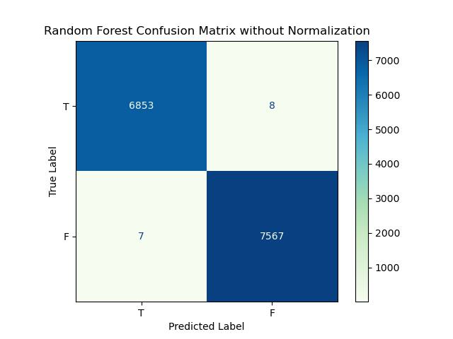

**Fig 11:** *confusion matrix*

Building so, we have computed that

✔ True Positives (**TP**) = 6853

✔ False Positives (**FP**) = 8

✔ False Negatives(**FN**) = 7

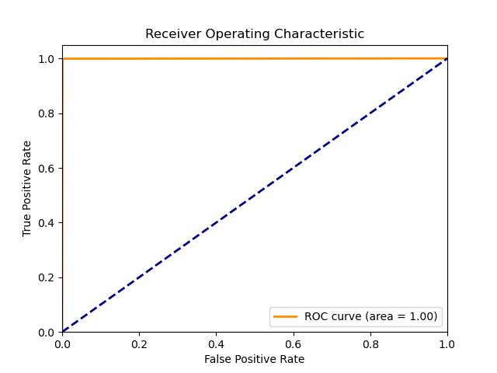

✔ True Negatives (**TN**) = 7567

Now we will be preparing the classification report of our Random Forest Classifier model.

|  |  |  |  |  |  |
| --- | --- | --- | --- | --- | --- |
| **Classification Report of Random Forest model** | | | | | |
| **Accuracy** | | | 0.99 | | |
|  | **precision** | **recall** | | **f1- score** | **support** |
| **0** | 1.00 | 1.00 | | 1.00 | 6861 |
| **1** | 1.00 | 1.00 | | 1.00 | 7574 |

**Table 13:** *classification report*

## XGBoost model:

* + **Introduction: XGBoost** is a powerful and scalable machine learning algorithm that is an implementation of gradient boosted decision trees designed for speed and performance. It is widely used for both classification and regression tasks.
  + Key Features:
* **Gradient Boosting**: XGBoost builds an ensemble of trees sequentially, where each new tree corrects errors made by the previous ones. It optimises a differentiable loss function by adding new models.
* **Regularisation**: XGBoost includes regularisation terms (L1 and L2) to control overfitting, which helps improve generalisation and model performance.
* **Handling Missing Data**: XGBoost can handle missing data within the dataset by learning the best direction to split.
* **Parallelization**: It supports parallel processing, which speeds up training on large datasets.
* **Tree Pruning**: XGBoost uses a technique called "max_depth" to limit the depth of the trees, and it performs tree pruning to remove branches that do not contribute significantly to the final prediction.
  + Working Mechanism:
* Boosting: Boosting is an ensemble technique that combines the predictions of several base estimators to improve robustness over a single estimator.
* Additive Training: Models are trained sequentially, and each new model focuses on reducing the residual errors of the previous models.
* Objective Function: XGBoost uses a combination of the loss function and a regularisation term to ensure the model does not overfit.

**The Way we have implemented in our Project:**

**Importing Necessary Libraries:**

from sklearn.pipeline import Pipeline

from xgboost import XGBClassifier

from sklearn.metrics import accuracy_score, classification_report, confusion_matrix

This imports the XGBClassifier class from xgboost module, as well as various evaluation metrics from the metrics module.

**Instantiate the XGBoost Model:**

xgb_pipe = Pipeline(steps=[

('step1', preprocessor),

('step2', XGBClassifier(use_label_encoder=False, eval_metric='logloss'))

])

This creates an instance of the XGBClassifier class, suitable for classification, particularly good for structured/tabular data. Setting the label_encoder to **False** tells XGBoost not to use its deprecated internal label encoder. Eval_metric specifies the **evaluation metric** used during training and 'logloss' (logarithmic loss or cross-entropy loss) is appropriate for **classification** problems.

**Training the Model:**

xgb_pipe.fit(X_train, y_train)

This trains the XGBoost model on the training data, where X_train represents the input features (preprocessed and transformed into numerical vectors) and y_train represents the corresponding target labels.

**Making Predictions:**

y_pred_xgb = xgb_pipe.predict(X_test)

Here, the predict() method is used to generate predictions on the test data.

**Model Evaluation:**

print("XGBoost Accuracy:", accuracy_score(y_test, y_pred_xgb))

print("\nClassification Report:\n", classification_report(y_test, y_pred_xgb))

print("\nConfusion Matrix:\n", confusion_matrix(y_test, y_pred_xgb))

Here, we evaluate the model's performance using various metrics like accuracy and generate classification report and confusion matrix.

**Results:**

XGBoost Accuracy: 0.997783165916176

**Classification Report:**

**precision recall f1-score support**

**0 1.00 1.00 1.00 6861**

**1 1.00 1.00 1.00 7574**

**accuracy 1.00 14435**

**macro avg 1.00 1.00 1.00 14435**

**weighted avg 1.00 1.00 1.00 14435**

**Confusion Matrix:**

**[[6839 22]**

**[ 10 7564]]**

Now we created a confusion matrix to view the actual and predicted test results. Given below is the confusion matrix:

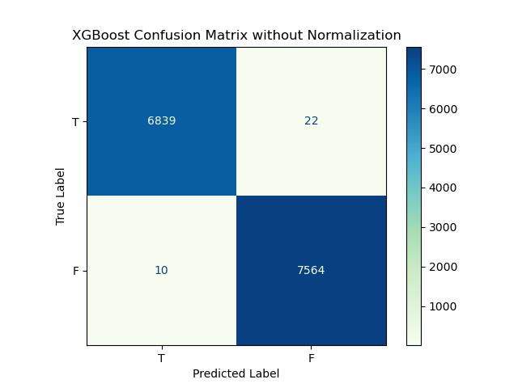

**Fig 12:** *confusion matri*

So, we have computed that

✔ True Positives (**TP**) = 6839

✔ False Positives (**FP**) = 22

✔ False Negatives (**FN**) = 10

✔ True Negatives (**TN**) = 7564

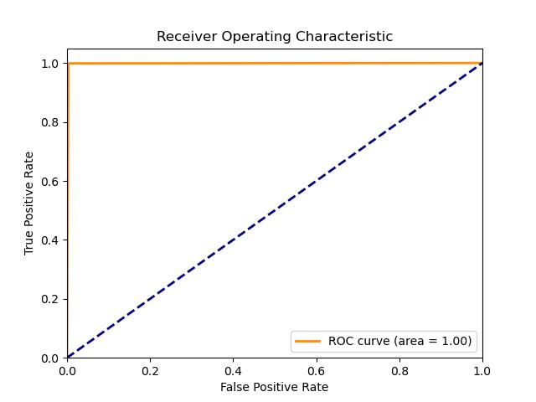

Now we will be preparing the classification report of our XGBoost model.

|  |  |  |  |  |  |
| --- | --- | --- | --- | --- | --- |
| **Classification Report of XGBoost model** | | | | | |
| **Accuracy** | | | 0.997 | | |
|  | **precision** | **recall** | | **f1-score** | **support** |
| **0** | 1.00 | 1.00 | | 1.00 | 6861 |
| **1** | 1.00 | 1.00 | | 1.00 | 7574 |

**Table 10:** *classification report*

The metrics used in classification report are:

1. **Accuracy-** the number of correctly classified data instances over the total number of data instances.

*Accuracy= (TP+TN)/ (TN+TP+FN+FP)*

1. **Precision-** measures how many of the samples predicted as positive are actually positive. *Precision= TP/ (TP + FP)*
2. **Recall-** measures how many of the positive samples are captured by the positive predictions. *Recall= TP/ (TP + FN)*
3. **F1-score or f-measure-** which is equal to the harmonic mean of precision and recall. *F1-score= 2 * (precision * recall)/ (precision + recall)*
4. **Support-** the number of instances in a dataset that belong to a particular class. It is also known as the frequency of a class.

## Support Vector Machine (SVM) Classifier:

* + **Introduction: Support Vector Machine or SVM** is one of the most popular Supervised Learning algorithms, which is used for Classification as well as Regression problems. However, primarily, it is used for Classification problems in Machine Learning.

The goal of the SVM algorithm is to create the best line or decision boundary that can segregate n- dimensional space into classes so that we can easily put the new data point in the correct category in the future. This best decision boundary is called a hyperplane.

SVM chooses the extreme points/vectors that help in creating the hyperplane. These extreme cases are called support vectors, and hence the algorithm is termed as Support Vector Machine. Consider the below diagram in which there are two different categories that are classified using a decision boundary or hyperplane:

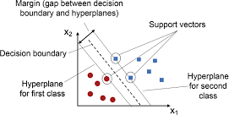

* + Terminologies:

**Fig 13:** *SVM Diagra*

**Hyperplane**: There can be multiple lines/decision boundaries to segregate the classes in n-dimensional space, but we need to find out the best decision boundary that helps to classify the data points. This best boundary is known as the hyperplane of SVM.

**Support Vectors:** The data points or vectors that are the closest to the hyperplane and which affect the position of the hyperplane are termed as Support Vector. These vectors support the hyperplane, hence called a Support vector.

* + Types of SVM:

**Linear SVM:** Linear SVM is used for linearly separable data, which means if a dataset can be classified into two classes by using a single straight line, then such data is termed as linearly separable data, and classifier is used called as Linear SVM classifier.

**Non-linear SVM:** Non-Linear SVM is used for non-linearly separated data, which means if a dataset cannot be classified by using a straight line, then such data is termed as non-linear data and classifier used is called as Non-linear SVM classifier.

* + Working Principle:

**Model Representation:** SVM represents the data in a high-dimensional space and finds the hyperplane that maximises the margin between the classes. The data points closest to the hyperplane are called support vectors.

**Hyperplane:** A hyperplane in an n-dimensional space is a flat affine subspace of dimension n−1 that separates the data into different classes.

**Margin:** The margin is the distance between the hyperplane and the nearest data points from each class. SVM aims to maximise this margin to ensure the best separation between classes.

**Kernels:** SVM can efficiently handle non-linearly separable data by using kernel functions to transform the data into a higher-dimensional space. Common kernel functions include:

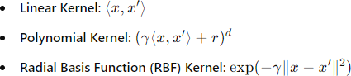

* + Evaluation:

**Metrics:** Common evaluation metrics for SVM include accuracy, precision, recall, F1-score, and area under the ROC curve (AUC-ROC).

**Cross-Validation:** SVM models are often evaluated using techniques like k-fold cross-validation to assess their generalisation performance on unseen data.

In summary, SVM is a powerful and flexible classification algorithm that can handle both linear and non- linear data. Its ability to create complex decision boundaries makes it suitable for a wide range of applications, although it may require careful tuning and significant computational resources for large datasets.

**The Way we have implemented in our Project:**

**Importing Necessary Libraries:**

from sklearn.svm import SVC

from sklearn.metrics import accuracy_score, classification_report, confusion_matrix

This imports the SVC class from sklearn's svm module, as well as various evaluation metrics from the metrics module.

**Instantiate the SVM Model:**

svc_pipe = Pipeline([

('preprocessor', preprocessor),

('classifier', SVC(kernel='rbf', probability=True, random_state=42))

])

This creates an instance of the SVC class with a ‘rbf’ kernel, probability = True means we need the the results in terms of probability , and a random state for reproducibility.

**Training the Model:**

svc_pipe.fit(X_train, y_train)

**Making Predictions:**

**_**pred_svc = svc_pipe.predict(X_test)

Here, the predict() method is used to generate predictions on the test data.

**Model Evaluation:**

print("Accuracy:", accuracy_score(y_test, y_pred_svc))

print("SVC Classifier Report:\n")

print(classification_report(y_test, y_pred_svc))

print("Confusion Matrix:\n", confusion_matrix(y_test, y_pred_svc))

Here, we evaluate the model's performance using various metrics like accuracy and generate classification report as well as the confusion matrix for the model.

**Results:**

Accuracy: 0.9590578455143748

**SVC Classifier Report:**

**precision recall f1-score support**

**0 0.96 0.95 0.96 6861**

**1 0.96 0.97 0.96 7574**

**accuracy 0.96 14435**

**macro avg 0.96 0.96 0.96 14435**

**weighted avg 0.96 0.96 0.96 14435**

**Confusion Matrix:**

[[6518 343]

[ 248 7326]]

Now we created a confusion matrix to view the actual and predicted test results. Given below is the confusion matrix:

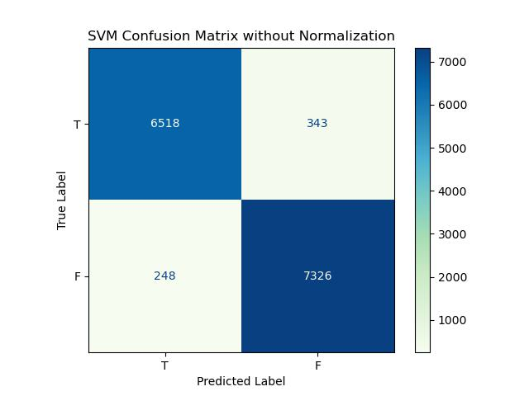

**Fig 14:** *confusion matrix*

So, we have computed that

✔ True Positives (**TP**) = 6518

✔ False Positives (**FP**) = 343

✔ False Negatives (**FN**) = 248

✔ True Negatives (**TN**) = 7326

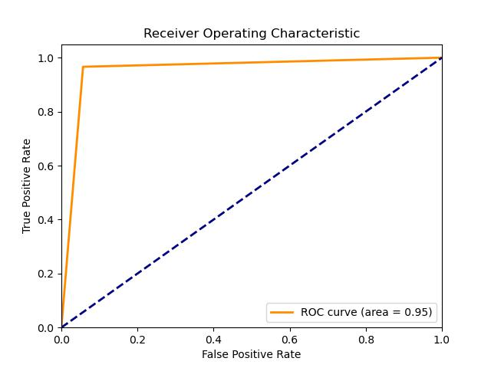

**CLASIFICATION REPORT OF SVM**

|  |  |  |  |  |  |
| --- | --- | --- | --- | --- | --- |
| **Classification Report of SVM model** | | | | | |
| **Accuracy** | | | 0.959 | | |
|  | **precision** | **recall** | | **f1- score** | **support** |
| **0** | 0.96 | 0.95 | | 0.96 | 6861 |
| **1** | 0.96 | 0.97 | | 0.96 | 7574 |

**Table 16:** *classification report*

## AdaBoost(Adaptive Boosting) Classifier:

* + **Introduction: AdaBoost (Adaptive Boosting)** is an ensemble learning algorithm that combines multiple **weak learners** (typically decision stumps) to create a **strong classifier**. It focuses on improving prediction accuracy by giving more weight to incorrectly classified samples at each iteration. In the context of this project, AdaBoost is used to predict the outcome of IPL matches (win/loss) based on match-related features like current run rate (CRR), required run rate (RRR), balls left, wickets, etc.
* Working Principle:

AdaBoost works in the following way:

1. **Initialize weights** for all training instances equally.
2. For each iteration:

• Train a weak learner (e.g., decision stump).

• Evaluate errors: Misclassified samples are given **higher weights**.

• Train the next weak learner on the **re-weighted** data.

1. Combine all weak learners into a single strong model using **weighted voting**, where more accurate learners have higher influence.

* **Model Representation:**
* The final AdaBoost model is a **weighted sum of weak classifiers**:

H(x) = sign(Σ from t = 1 to T of αₜ · hₜ(x))

**Where:**

* ht​(x) is the prediction of the t-th weak classifier
* αt is the weight (importance) of that classifier
* T is the total number of boosting rounds

In an IPL match scenario, weak classifiers might individually make simple decisions like:

* “If runs left < 30, predict win”
* “If wickets < 3 and RRR > 10, predict loss”

These simple rules, when combined and weighted properly, lead to strong performance.

**Splitting Criteria:**

The **base learner** in AdaBoost is often a **decision stump** — a tree with only one split. The splitting criterion for these trees is usually:

* **Gini Impurity** or **Entropy**, similar to full decision trees.

However, AdaBoost itself does **not use a new splitting criterion**. Instead, it **modifies the sample weights**:

* Samples that are misclassified are given higher importance in the next round.
* The base learners use the **weighted training data** to perform splits that better focus on hard examples.
  + Evaluation:

**Metrics:** To evaluate the performance of the AdaBoost classifier in the IPL Win Predictor model, we use:

1. **Accuracy**: Percentage of correctly predicted match outcomes.
2. **Confusion Matrix**: Shows how many wins and losses were correctly/incorrectly predicted.
3. **Precision, Recall, and F1 Score**: Especially useful if win/loss classes are imbalanced.
4. **ROC-AUC Score**: Measures model's ability to discriminate between winning and losing cases.
5. **Cross-validation**: Ensures the model performs well on unseen data and avoids overfitting.

AdaBoost offers a powerful alternative to traditional classifiers, especially when simpler models like decision trees are prone to underfitting. By focusing on mistakes and iteratively improving weak models, AdaBoost achieved strong predictive performance in the IPL Win Predictor. It successfully captured match dynamics and delivered consistent results in predicting the outcome based on key features.

**The Way we have implemented in our Project:**

**Importing Necessary Libraries:**

from sklearn.ensemble import AdaBoostClassifier

from sklearn.tree import DecisionTreeClassifier

from sklearn.metrics import accuracy_score, classification_report, confusion_matrix

This imports the AdaBoostClassifier class from sklearn's ensemble module, as well as various evaluation metrics from the metrics module.

**Instantiate the AdaBoost Model:**

ada_model = AdaBoostClassifier(

estimator=DecisionTreeClassifier(max_depth=1),

n_estimators=50,

learning_rate=1.0,

random_state=42

)

This creates an instance of the AdaBoostClassifier class with estimator as a Decision Tree with max depth = 1, n_estimators=50 means AdaBoost will build **50 decision stumps**, one at a time, each correcting the mistakes of the previous one, learning rate = 1 is the default and means full weight is given to each learner. and random state = 42 sets the **random seed** to make results **reproducible**.

ada_pipe = Pipeline(steps=[

('step1', preprocessor),

('step2', ada_model)

])

This is pipelining step for the AdaBoost model with preprocessing of the data.

**Training the Model:**

ada_pipe.fit(X_train, y_train)

This trains the AdaBoost model on the training data, where X_train represents the input features (preprocessed and transformed into numerical vectors) and y_train represents the corresponding target labels.

**Making Predictions:**

y_pred_ada = ada_pipe.predict(X_test)

Here, the predict() method is used to generate predictions on the test data.

**Model Evaluation:**

print("Accuracy:", accuracy_score(y_test, y_pred_ada))

print("\nClassification Report:\n", classification_report(y_test, y_pred_ada))

print("\nConfusion Matrix:\n", confusion_matrix(y_test, y_pred_ada))

Here, we evaluate the model's performance using various metrics like accuracy, classification report and confusion matrix.

**Results:**

Accuracy: 0.7564253550398338

**Classification Report:**

**precision recall f1-score support**

**0 0.73 0.78 0.75 6861**

**1 0.79 0.73 0.76 7574**

**accuracy 0.76 14435**

**macro avg 0.76 0.76 0.76 14435**

**weighted avg 0.76 0.76 0.76 14435**

**Confusion Matrix:**

[[5366 1495]

[2021 5553]]

Now we created a confusion matrix to view the actual and predicted test results. Given below is the confusion matrix:

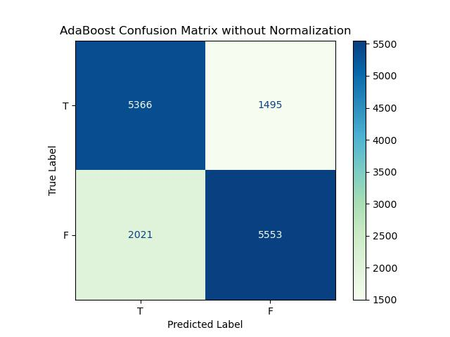

**Fig 16:** *confusion matrix*

So, we have computed that

✔ True Positives (**TP**) = 5366

✔ False Positives (**FP**) = 1495

✔ False Negatives (**FN**) = 2021

✔ True Negatives (**TN**) = 5533

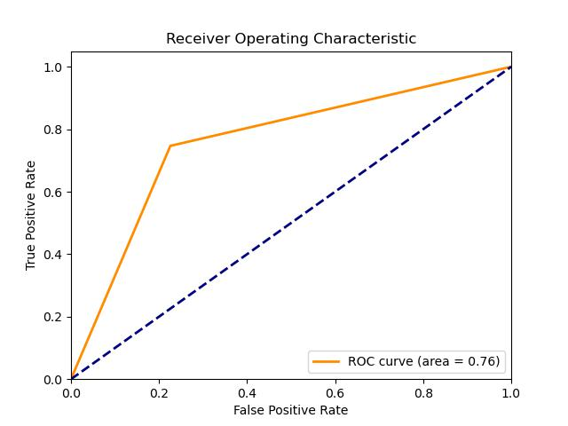

Now we will be preparing the classification report of our AdaBoost model.

|  |  |  |  |  |  |
| --- | --- | --- | --- | --- | --- |
| **Classification Report of AdaBoost model** | | | | | |
| **Accuracy** | | | 0.756 | | |
|  | **precision** | **recall** | | **f1- score** | **support** |
| **0** | 0.73 | 0.77 | | 0.75 | 6743 |
| **1** | 0.79 | 0.75 | | 0.77 | 7692 |

**Table 19:** *classification report*

## Comparison of the Models trained

We trained 6 models using the 6 algorithms viz.

1. *Logistic Regression*
2. *Random Forest classifier model*
3. *XGBoost classifier model*
4. *Support vector classifier model*
5. *AdaBoost classifier model*

The 5 models had different accuracy. The comparisons of the accuracies of the models are given below:

|  |  |
| --- | --- |
| **Model** | **Accuracy (in %)** |
| Logistic Regression | 80 |
| Random Forest classifier model | 99.83 |
| XGBoost classifier model | 99.67 |
| Support vector classifier model | 95.71 |

|  |  |
| --- | --- |
| AdaBoost model | 75.96 |

**Table 24:** *Comparison of trained model’s accuracy*

**COMPARISON BETWEEN VARIOUS MODELS**

|  |  |  |  |  |  |
| --- | --- | --- | --- | --- | --- |
| **Model** | **Logistic Regression** | **Random Forest** | **AdaBoost** | **XGBoost** | **Support Vector Machine** |
| **Accuracy** | **0.802** | **0.998** | **0.768** | **0.997** | **0.956** |
| **Precision** | **0.804** | **0.998** | **0.792** | **0.997** | **0.954** |
| **Recall** | **0.826** | **0.999** | **0.759** | **0.998** | **0.967** |
| **F1-Score** | **0.815** | **0.998** | **0.775** | **0.998** | **0.960** |

The following bar graph shows the accuracy comparison in graphical way:

**Fig 15:** *Comparison of accuracy of 6 trained models*

Given the superior performance metrics of the Random Forest model, proceeding with it for our application is a well- founded decision. The Random Forest model's high accuracy, precision, recall, and F1 score indicate that it is the most effective at correctly classifying the data, minimising both false positives and false negatives.

# Test Dataset

After pre-processing of the test dataset had been done, we trained the models with 100% of the train dataset given and used those trained models to predict the outcome for each input in the test dataset. The outcomes obtained are tabulated as below:

|  |  |  |
| --- | --- | --- |
| **Classification Models** | **Outcomes** | |
| **0** | **1** |
| **Logistic Regression** | 6586 | 7849 |
| **Random Forest** | 6734 | 7701 |
| **AdaBoost** | 7169 | 7266 |
| **XGBoost** | 6721 | 7714 |
| **SVM** | 6619 | 7816 |

USER INTERFACE DESIGN

The user interface of the IPL Win Predictor project is designed to provide an intuitive and interactive experience for users to predict the outcome of an ongoing cricket match based on various input parameters. Here’s a breakdown of the UI components:

1. **Title and Team Selection**:
   * The title "🏏 IPL Win Predictor" sets the context for the application.
   * Users can select the batting and bowling teams from a dropdown list, ensuring ease of team selection.
2. **City Selection**:
   * A dropdown menu allows users to choose the city where the match is being hosted, influencing match conditions.
3. **Target Score and Current Match Situation**:
   * Users input the target score and current score, with validation to ensure the current score is less than the target score to proceed.
   * They also input the overs completed and the number of wickets fallen, crucial factors in determining match dynamics.
4. **Prediction and Probability Calculation**:
   * Upon clicking the "Predict Probability" button, the application calculates various match parameters:
     + Runs left to score and balls left to play.
     + Wickets remaining and current run rates (CRR) and required run rates (RRR).
   * Using a pre-trained machine learning model (pipe.pkl), the application predicts the probability of winning and losing for the selected teams.
5. **Result Display**:
   * Results are displayed in a clear and visually appealing manner:
     + **Win Probability**: Shows the predicted win probability for both the batting and bowling teams in percentage format.
     + **Pie Chart**: A graphical representation using a pie chart illustrates the win and loss probabilities, enhancing the visualization of outcomes.
6. **Feedback and Interaction**:
   * Interactive elements like toast messages alert users to input errors or necessary corrections.
   * The interface is designed to be responsive and user-friendly, ensuring seamless interaction and real-time feedback.

This UI design ensures that cricket enthusiasts and analysts can efficiently predict match outcomes based on real-time match data and historical statistics, making it a valuable tool for cricket fans and professionals alike.

**The Way we have implemented in our Project:**

**import** streamlit **as** st

**import** pickle

**import** sklearn

**import** pandas **as** pd

**import** plotly**.**express **as** px

teams **=** [

    'Sunrisers Hyderabad'**,**

    'Mumbai Indians'**,**

    'Royal Challengers Bangalore'**,**

    'Kolkata Knight Riders'**,**

    'Punjab Kings'**,**

    'Chennai Super Kings'**,**

    'Rajasthan Royals'**,**

    'Delhi Capitals'

]

cities **=** ['Hyderabad'**,** 'Bangalore'**,** 'Mumbai'**,** 'Indore'**,** 'Kolkata'**,** 'Delhi'**,**

       'Chandigarh'**,** 'Jaipur'**,** 'Chennai'**,** 'Cape Town'**,** 'Port Elizabeth'**,**

       'Durban'**,** 'Centurion'**,** 'East London'**,** 'Johannesburg'**,** 'Kimberley'**,**

       'Bloemfontein'**,** 'Ahmedabad'**,** 'Cuttack'**,** 'Nagpur'**,** 'Dharamsala'**,**

       'Visakhapatnam'**,** 'Pune'**,** 'Raipur'**,** 'Ranchi'**,** 'Abu Dhabi'**,**

       'Sharjah'**,** 'Mohali'**,** 'Bengaluru']

pipe **=** pickle**.**load(open('pipe.pkl'**,**'rb'))

st**.**title('🏏 IPL Win Predictor')

col1**,** col2 **=** st**.**columns(2)

**with** col1**:**

    batting_team **=** st**.**selectbox('Select the batting team'**,**sorted(teams))

team2 **=** [team **for** team **in** teams **if** team **!=** batting_team]

**with** col2**:**

    bowling_team **=** st**.**selectbox('Select the bowling team'**,**sorted(team2))

selected_city **=** st**.**selectbox('Select host city'**,**sorted(cities))

target **=** st**.**number_input("🎯 Target Score"**,** **min_value=**1**,** **max_value=**350**,** **step=**1**,** **format=**"%d")

col3**,**col4**,**col5 **=** st**.**columns(3)

**with** col3**:**

    score **=** st**.**number_input("🏏 Current Score"**,** **min_value=**0**,** **max_value=**target**,** **step=**1**,** **format=**"%d")

**if**( score **>=** target)**:**

        st**.**toast("Score should be less than target"**,** **icon=**"⚠️")

        st**.**stop()

**with** col4**:**

    overs **=** st**.**number_input("⏱ Overs Completed"**,** **min_value=**1**,** **max_value=**20**,** **step=**1**,** **format=**"%d")

**with** col5**:**

    wickets **=** st**.**number_input("🚨 Wickets Fallen"**,** **min_value=**0**,** **max_value=**10**,** **step=**1**,** **format=**"%d")

**if** st**.**button('Predict Probability')**:**

    runs_left **=** target **-** score

    balls_left **=** 120 **-** (overs**\***6)

    wickets **=** 10 **-** wickets

    crr **=** score**/**overs

    rrr **=** (runs_left**\***6)**/**balls_left

    input_df **=** pd**.**DataFrame({'batting_team'**:**[batting_team]**,**'bowling_team'**:**[bowling_team]**,**'city'**:**[selected_city]**,**'runs_left'**:**[runs_left]**,**'balls_left'**:**[balls_left]**,**'wickets'**:**[wickets]**,**'total_runs_x'**:**[target]**,**'crr'**:**[crr]**,**'rrr'**:**[rrr]})

    result **=** pipe**.**predict_proba(input_df)

    loss **=** result[0][0]

    win **=** result[0][1]

    col_result**,** col_chart **=** st**.**columns([1**,** 1.5])

**with** col_result**:**

        st**.**subheader("🔮 Win Probability")

        st**.**write(f"### 🟢 {batting_team}: **{round(win **\*** 100)}%**")

        st**.**write(f"### 🔴 {bowling_team}: **{round(loss **\*** 100)}%**")

**with** col_chart**:**

*# Pie Chart*

        pie_df **=** pd**.**DataFrame({

            'Outcome'**:** [f'{batting_team} Win'**,** f'{bowling_team} Win']**,**

            'Probability'**:** [win**,** loss]

        })

        fig_pie **=** px**.**pie(

            pie_df**,** **values=**'Probability'**,** **names=**'Outcome'**,**

**color_discrete_sequence=**['#00cc96'**,** '#EF553B']**,**

**title=**''**,**

**hole=**0.4

        )

        st**.**plotly_chart(fig_pie**,** **use_container_width=**True)

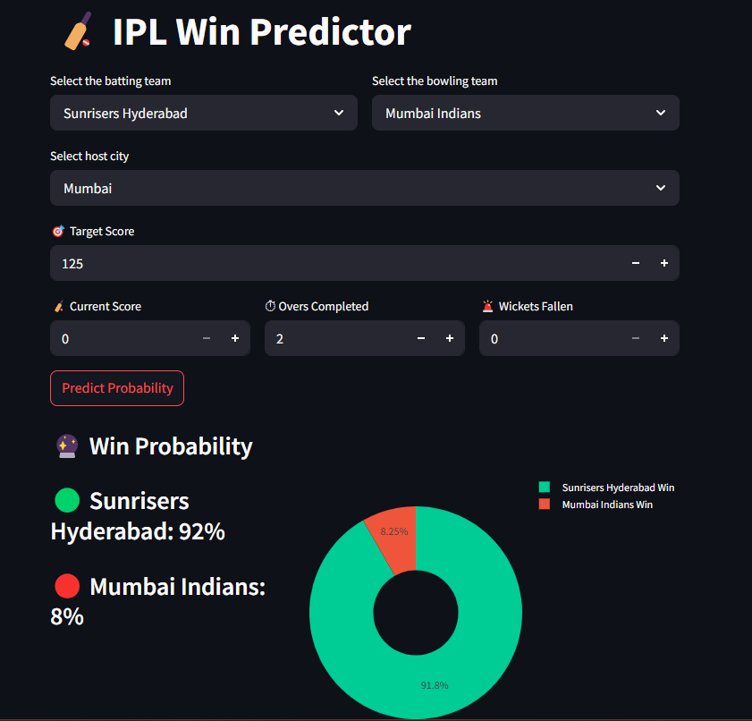

# Codes

# Importing required modules

import numpy as np

import pandas as pd

import matplotlib.pyplot as plt

import seaborn as sns

# Reading the datsets

match_df = pd.read_csv("Datasets/matches.csv")

delivery_df = pd.read_csv("Datasets/deliveries.csv")

match_df.shape



delivery_df.shape



# match dataframe

match_df.head()

# delivery dataframe

delivery_df.head()

# Checking the runs c=scored in bth the innnings of each match an storing it in another dataframe

total_score_df = delivery_df.groupby(['match_id', 'inning']).sum()['total_runs'].reset_index()

# we just need the first inning total for our calculation

total_score_df = total_score_df[total_score_df['inning'] == 1]

total_score_df

# Joining the dataframes

merge = match_df.merge(total_score_df[['match_id', 'total_runs']], left_on = 'id', right_on= 'match_id')

merge

merge['team1'].unique()

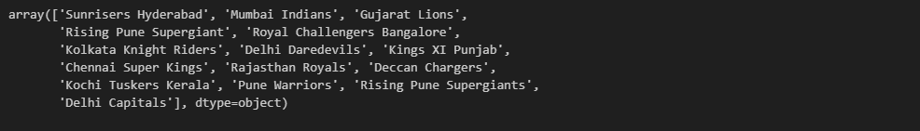

# Name of the teams fro the datasets that are playing till today

teams = [

    'Sunrisers Hyderabad',

    'Mumbai Indians',

    'Royal Challengers Bangalore',

    'Kolkata Knight Riders',

    'Punjab Kings',

    'Chennai Super Kings',

    'Rajasthan Royals',

    'Delhi Capitals'

]

# Changing the name of the playing teams to their current names

merge['team1'] = merge['team1'].str.replace('Delhi Daredevils', 'Delhi Capitals')

merge['team2'] = merge['team2'].str.replace('Delhi Daredevils', 'Delhi Capitals')

merge['team1'] = merge['team1'].str.replace('Deccan Chargers', 'Sunrisers Hyderabad')

merge['team2'] = merge['team2'].str.replace('Deccan Chargers', 'Sunrisers Hyderabad')

merge['team1'] = merge['team1'].str.replace('Kings XI Punjab', 'Punjab Kings')

merge['team2'] = merge['team2'].str.replace('Kings XI Punjab', 'Punjab Kings')

# We only need the teams that are playing till current date, so we are dropping others

merge = merge[merge['team1'].isin(teams)]

merge = merge[merge['team2'].isin(teams)]

merge.shape



# Matches that are affected by DLS method('0' means not affected, '1' means affected)

merge['dl_applied'].value_counts()



# We are keeping only those matches that are not affected by DLS

merge = merge[merge['dl_applied'] == 0]

merge

# Taking only the required columns

merge = merge[['match_id', 'city', 'winner', 'total_runs']]

merge_df = merge.merge(delivery_df, on = 'match_id')

merge_df

merge_df = merge_df[merge_df['inning'] == 2]

merge_df.shape



# Checking the null values from datset

print(merge_df.isnull().sum())

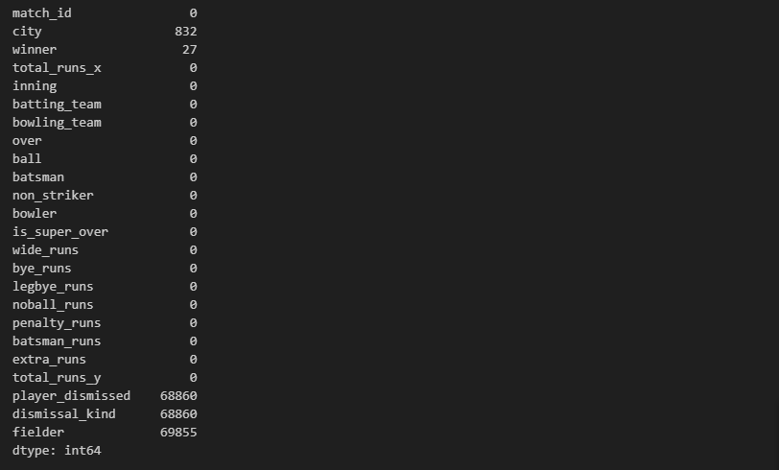

# Filling the missing values in the city column with the mode of their records and the winner column with 'No result

merge_df = merge_df.assign(

    city = merge_df['city'].fillna(merge_df['city'].mode()[0]),

    winner = merge_df['winner'].fillna('No Result')

)

# Checking after filling the missing values

print(merge_df.isnull().sum())

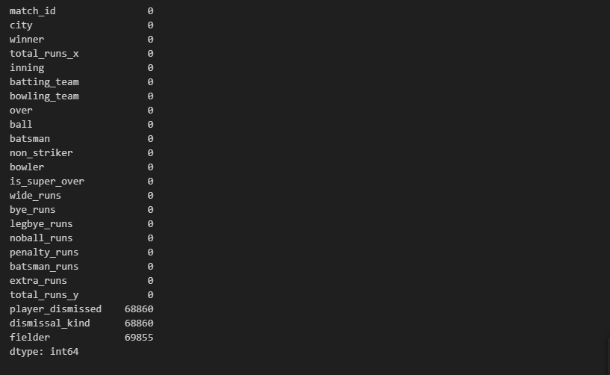

# Check Data Types of each column

print(merge_df.dtypes)

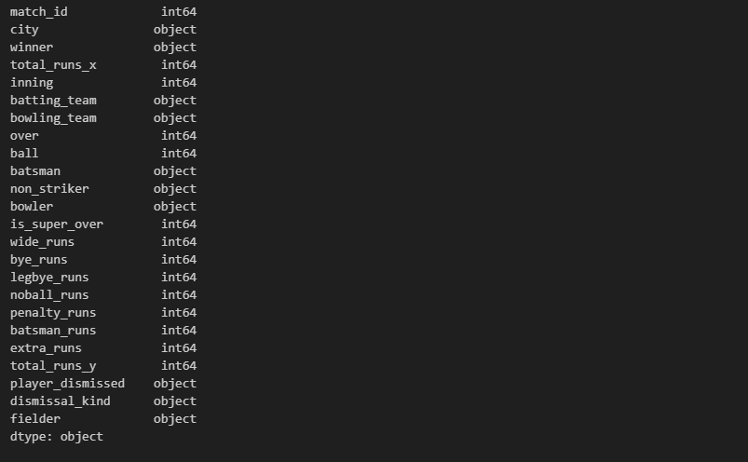

# Check Unique Values in Key Columns

print(merge_df['winner'].unique())

print(merge_df['batting_team'].unique())

print(merge_df['bowling_team'].unique())

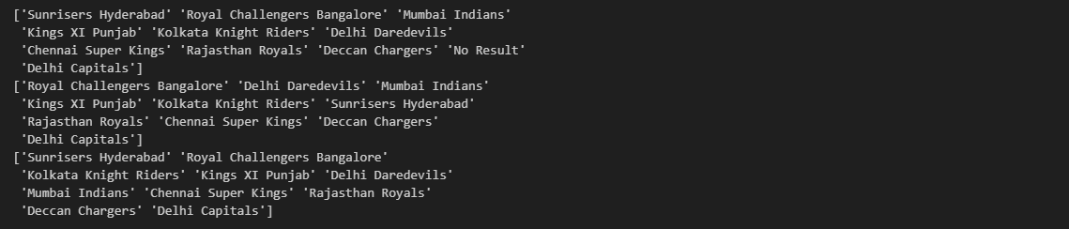

# Replacing the name of the teams with their current names in the merged dataframe

merge_df['batting_team'] = merge_df['batting_team'].str.replace('Deccan Chargers', 'Sunrisers Hyderabad')

merge_df['bowling_team'] = merge_df['bowling_team'].str.replace('Deccan Chargers', 'Sunrisers Hyderabad')

merge_df['winner'] = merge_df['winner'].str.replace('Deccan Chargers', 'Sunrisers Hyderabad')

merge_df['batting_team'] = merge_df['batting_team'].str.replace('Delhi Daredevils', 'Delhi Capitals')

merge_df['bowling_team'] = merge_df['bowling_team'].str.replace('Delhi Daredevils', 'Delhi Capitals')

merge_df['winner'] = merge_df['winner'].str.replace('Delhi Daredevils', 'Delhi Capitals')

# After replacing checking Unique Values in Key Columns

print(merge_df['winner'].unique())

print(merge_df['batting_team'].unique())

print(merge_df['bowling_team'].unique())

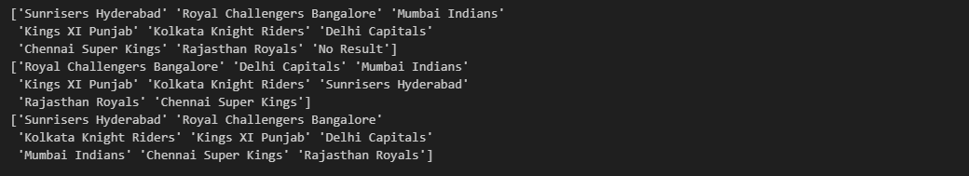

# One record was left in the previous changing i.e. 'Kingx XI Punjab' -> 'Punjab Kings'

merge_df['batting_team'] = merge_df['batting_team'].str.replace('King XI Punjab', 'Punjab Kings')

merge_df['bowling_team'] = merge_df['bowling_team'].str.replace('Kings XI Punjab', 'Punjab Kings')

merge_df['winner'] = merge_df['winner'].str.replace('Kings XI Punjab', 'Punjab Kings')

print(merge_df['batting_team'].unique())



# One of them giving errors due to spacing problems, that's why we used strip()

merge_df['batting_team'] = merge_df['batting_team'].str.strip()

merge_df['batting_team'] = merge_df['batting_team'].str.replace('Kings XI Punjab', 'Punjab Kings')

print(merge_df['batting_team'].unique())



# We take the help of cumulative sum to calculate the total runs ball by ball

merge_df['current_score'] = merge_df.groupby(['match_id'])['total_runs_y'].cumsum()

# Since the target is 1 run more than the actual runs scored in the first innings

merge_df['runs_left'] = (merge_df['total_runs_x'] - merge_df['current_score']) + 1

merge_df

# Calculating balls left after each ball

merge_df['balls_left'] = 126 - (merge_df['over']*6 + merge_df['ball'])

merge_df

# Filling the null values in the player dismised column with 0 and calculating the newly addded wickets columm using it

merge_df['player_dismissed'] = merge_df['player_dismissed'].fillna("0")

merge_df['player_dismissed'] = merge_df['player_dismissed'].apply(lambda x:x if x == "0" else "1")

merge_df['player_dismissed'] = merge_df['player_dismissed'].astype('int')

wickets = merge_df.groupby('match_id')['player_dismissed'].cumsum()

merge_df['wickets'] = 10 - wickets

merge_df.head()

# Current run rate(CRR)

merge_df['crr'] = (merge_df['current_score']*6)/(120 - merge_df['balls_left'])

#Required run rate(RRR)

merge_df['rrr'] = (merge_df['runs_left']*6)/merge_df['balls_left']

merge_df

# Result declare in form of 0 & 1

def result(row):

    return 1 if row['batting_team'] == row['winner'] else 0

# Deleting the unnecessary columns

merge_df  = merge_df.drop(columns = [ 'dismissal_kind', 'fielder'])

# Applying modified result column-wise to the dataframe

merge_df['result'] = merge_df.apply(result,axis=1)

# Again checking if there are some null values or not

print(merge_df.isnull().sum())

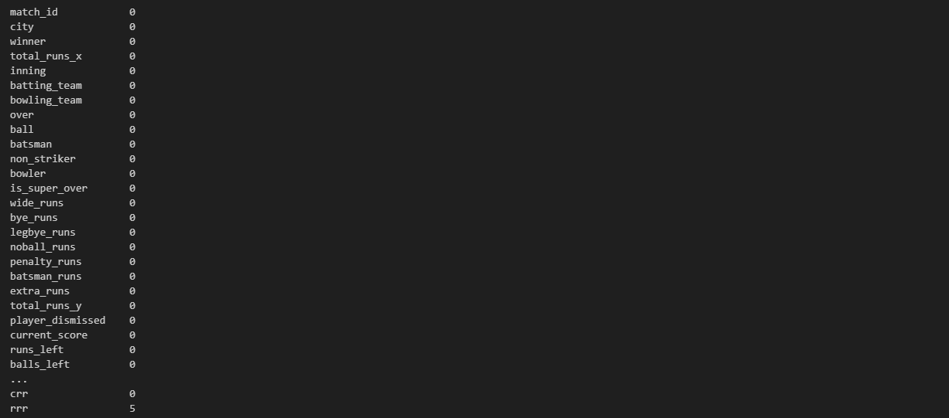

# Checking the first 5 rows

print(merge_df.head())

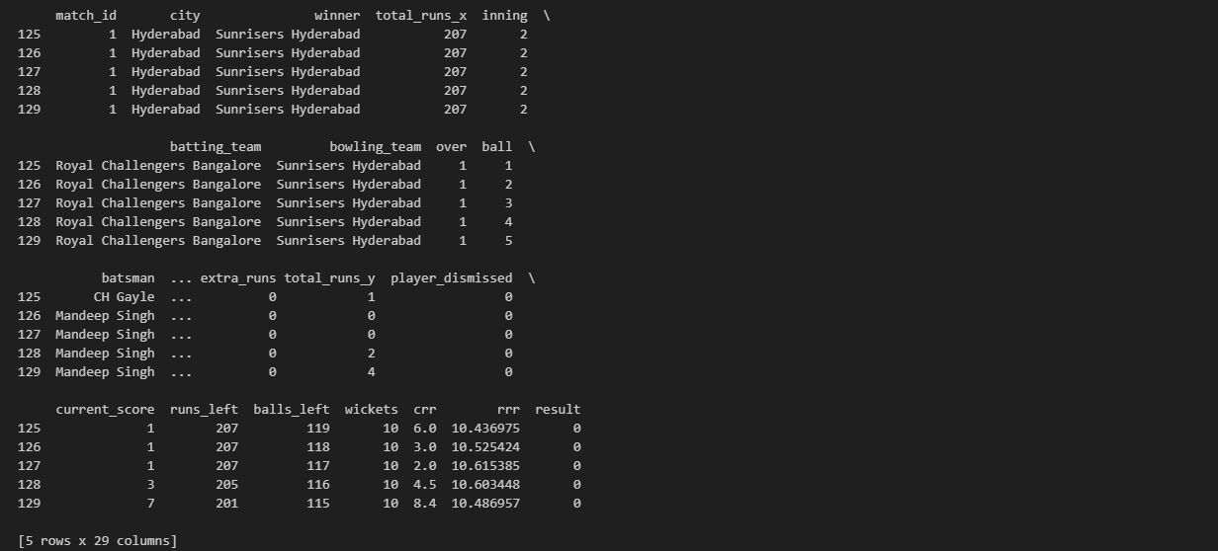

# Saving the cleaned datset into a new dataset

merge_df.to_csv('Datasets/final_dataset.csv', index=False)

# Creating a new dataframe with all the necessary features extracted from the previous dataframe

final_df = merge_df[['batting_team','bowling_team','city','runs_left','balls_left','wickets','total_runs_x','crr','rrr','result']]

final_df

# Suffling to check if everything is fine

final_df = final_df.sample(final_df.shape[0])

final_df

final_df['batting_team'].unique()



final_df['batting_team'] = final_df['batting_team'].str.replace('King XI Punjab', 'Punjab Kings')

final_df['bowling_team'].unique()



final_df.sample()

final_df['batting_team'] = final_df['batting_team'].str.replace('King XI Punjab', 'Punjab Kings')

final_df['batting_team'].unique()



final_df['bowling_team'].unique()



# We are using matplotlib and seaborn library for data visualization with different graphs and charts

# Total Matches Played by Each Team

team_matches = final_df['batting_team'].value_counts() + final_df['bowling_team'].value_counts()

plt.figure(figsize = (12,6))

sns.barplot(x = team_matches.index, y = team_matches.values, palette = 'Dark2')

plt.xticks(rotation = 90)

plt.xlabel("Teams")

plt.ylabel("Total Matches Played")

plt.title("Total Matches Played by Each Team")

plt.grid(axis='y', linestyle='--', alpha=0.7)

plt.show()

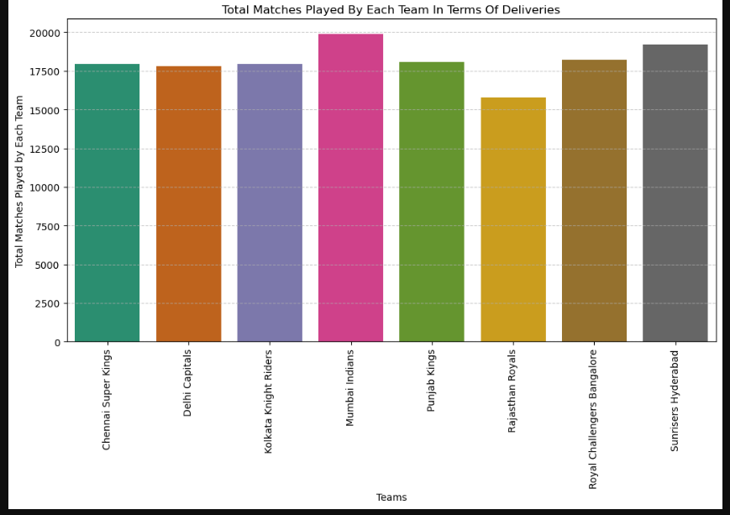

# Total number of wins by each team

winner_counts = merge_df['winner'].value_counts()

plt.figure(figsize = (12,6))

plt.pie(winner_counts, labels = winner_counts.index, autopct='%1.1f%%')

plt.title("Total Wins by Each Team")

plt.axis('equal')  # Equal aspect ratio ensures that pie is drawn as a circle.

plt.show()

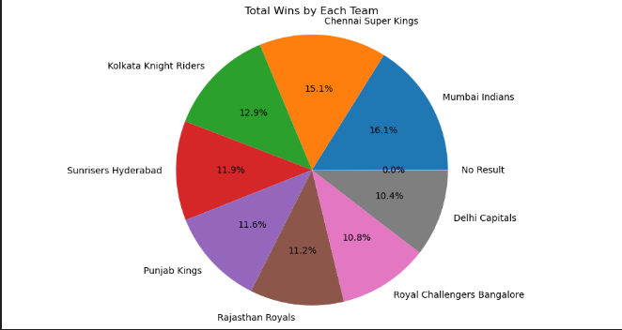

# Total runs scored by each team

team_total_runs = merge_df.groupby('batting_team')['total_runs_y'].sum().sort_values()

plt.figure(figsize=(12,6))

sns.barplot(x = team_total_runs.index, y = team_total_runs.values, palette = 'Set1')

plt.xticks(rotation=90)

plt.xlabel("Teams")

plt.ylabel("Total Runs Scored")

plt.title("Total Runs Scored by Each Team")

plt.show()

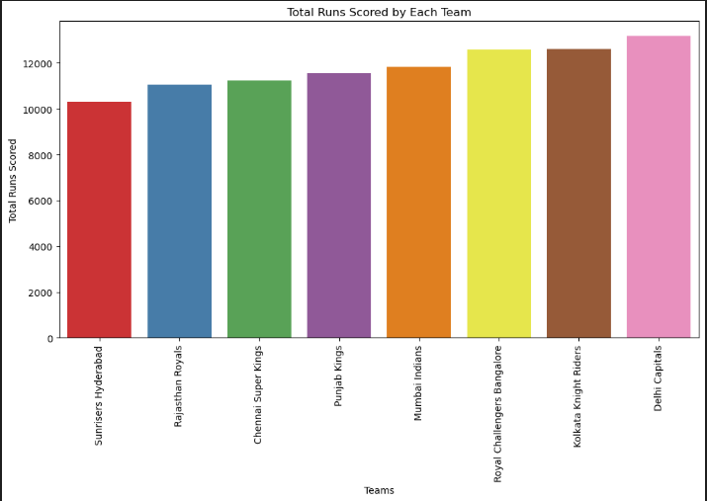

# Matches played in different cities

city_matches = merge_df['city'].value_counts()

plt.figure(figsize = (12,6))

sns.barplot(x = city_matches.index, y=city_matches.values, palette = 'Spectral')

plt.xticks(rotation = 90)

plt.xlabel("Cities")

plt.ylabel("Matches Hosted")

plt.title("Number of Matches Played in Different Cities")

plt.show()

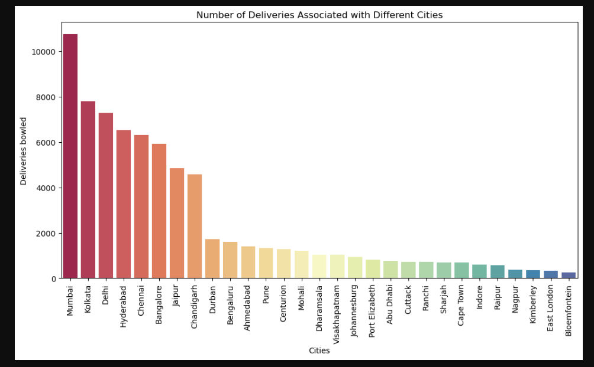

final_df.dropna(inplace=True)

# If 0 number of balls is left in a match, then it means the winner is already decide. So we drop the records where no balls left in a match

final_df = final_df[final_df['balls_left'] != 0]

from sklearn.model_selection import train_test_split

from sklearn.preprocessing import OneHotEncoder, StandardScaler

# Define features and target

X = final_df.drop('result', axis=1) # features

y = final_df['result'] # target

# Train/test split (80% training data and 20% testing data)

X_train, X_test, y_train, y_test = train_test_split(X, y, test_size=0.2, random_state=42)

# Columns

categorical_features = ['batting_team', 'bowling_team', 'city']

numeric_features = ['runs_left', 'balls_left', 'wickets', 'total_runs_x', 'crr', 'rrr']

# Train dataset

X_train

# Column transformer

from sklearn.compose import ColumnTransformer

preprocessor = ColumnTransformer([

    ('trf', OneHotEncoder(drop='first'), categorical_features),

    ('scaler', StandardScaler(), numeric_features)

])

from sklearn.linear_model import LogisticRegression

from sklearn.ensemble import RandomForestClassifier

from sklearn.pipeline import Pipeline

# Create a pipeline with logistic regression

log_pipe = Pipeline([

    ('preprocessor', preprocessor),

    ('classifier', LogisticRegression())

])

log_pipe.fit(X_train, y_train)

y_pred_log = log_pipe.predict(X_test)

from sklearn.metrics import accuracy_score, classification_report, confusion_matrix

print("Logistic Regression Accuracy:", accuracy_score(y_test, y_pred_log))

print("Classification Report:\n")

print(classification_report(y_test, y_pred_log))

cm = confusion_matrix(y_test, y_pred_log)

print("Confusion Matrix:\n", cm)

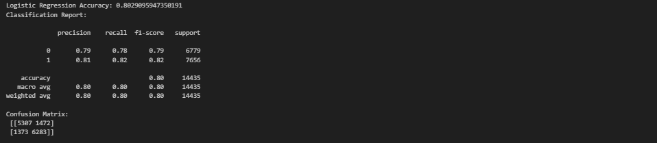

random_pipe = Pipeline(steps=[

    ('step1',preprocessor),

    ('step2',RandomForestClassifier())

])

random_pipe.fit(X_train,y_train)

y_pred_random = random_pipe.predict(X_test)

from sklearn.metrics import accuracy_score, classification_report, confusion_matrix

print("Random Forest Accuracy:", accuracy_score(y_test, y_pred_random))

print("\nClassification Report:\n", classification_report(y_test, y_pred_random))

print("\nConfusion Matrix:\n", confusion_matrix(y_test, y_pred_random))

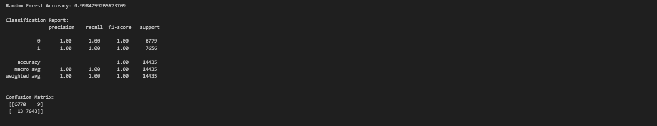

!pip install xgboost # Installing xgboost module in the system

from sklearn.pipeline import Pipeline

from xgboost import XGBClassifier

xgb_pipe = Pipeline(steps=[

    ('step1', preprocessor),

    ('step2', XGBClassifier(use_label_encoder=False, eval_metric='logloss'))

])

xgb_pipe.fit(X_train, y_train)

y_pred_xgb = xgb_pipe.predict(X_test)

from sklearn.metrics import accuracy_score, classification_report, confusion_matrix

print("XGBoost Accuracy:", accuracy_score(y_test, y_pred_xgb))

print("\nClassification Report:\n", classification_report(y_test, y_pred_xgb))

print("\nConfusion Matrix:\n", confusion_matrix(y_test, y_pred_xgb))

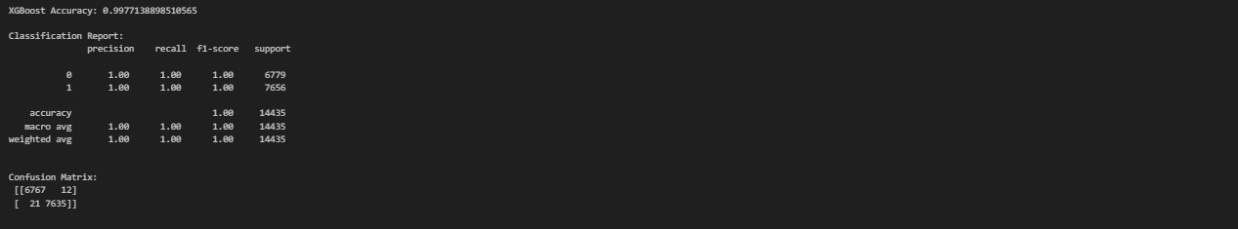

from sklearn.ensemble import AdaBoostClassifier

from sklearn.tree import DecisionTreeClassifier

from sklearn.metrics import accuracy_score, classification_report, confusion_matrix

# Create AdaBoost model with DecisionTreeClassifier as the base estimator

ada_model = AdaBoostClassifier(

    estimator=DecisionTreeClassifier(max_depth=1),

    n_estimators=50,

    learning_rate=1.0,

    random_state=42

)

ada_pipe = Pipeline(steps=[

    ('step1', preprocessor),

    ('step2', ada_model)

])

ada_pipe.fit(X_train, y_train)

y_pred_ada = ada_pipe.predict(X_test)

print("Accuracy:", accuracy_score(y_test, y_pred_ada))

print("\nClassification Report:\n", classification_report(y_test, y_pred_ada))

print("\nConfusion Matrix:\n", confusion_matrix(y_test, y_pred_ada))

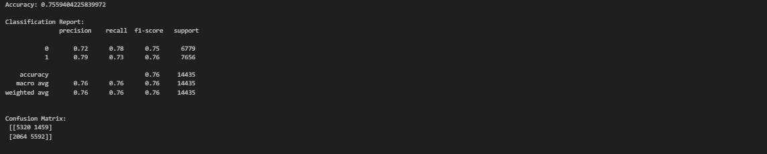

rom sklearn.svm import SVC

# Pipeline

svc_pipe = Pipeline([

    ('preprocessor', preprocessor),

    ('classifier', SVC(kernel='rbf', probability=True, random_state=42))

])

# Train

svc_pipe.fit(X_train, y_train)

# Predict and evaluate

y_pred_svc = svc_pipe.predict(X_test)

print("Accuracy:", accuracy_score(y_test, y_pred_svc))

print("SVC Classifier Report:\n")

print(classification_report(y_test, y_pred_svc))

print("Confusion Matrix:\n", confusion_matrix(y_test, y_pred_svc))

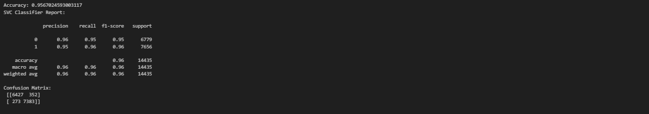

from sklearn.metrics import accuracy_score, precision_score, recall_score, f1_score, confusion_matrix

# Accuracy

print(f"Logistic Regression: {accuracy_score(y_test,y_pred_log)}")

print(f"Random Forest Classifier: {accuracy_score(y_test,y_pred_random)}")

print(f"AdaBoost Claasifer: {accuracy_score(y_test,y_pred_ada)}")

print(f"XGBoost Classifer: {accuracy_score(y_test,y_pred_xgb)}")

print(f"Support Vector Machine: {accuracy_score(y_test,y_pred_svc)}")



# Precision

print(f"Logistic Regression: {precision_score(y_test, y_pred_log)}")

print(f"Random Forest Classifer: {precision_score(y_test, y_pred_random)}")

print(f"AdaBoost Classifier: {precision_score(y_test, y_pred_ada)}")

print(f"XGBoost Classifier: {precision_score(y_test, y_pred_xgb)}")

print(f"Support Vector Machine: {precision_score(y_test, y_pred_svc)}")



# Recall

print(f"Logistic Regression: {recall_score(y_test, y_pred_log)}")

print(f"Random Forest Classifer: {recall_score(y_test, y_pred_random)}")

print(f"AdaBoost Classifier: {recall_score(y_test, y_pred_ada)}")

print(f"XGBoost Classifier: {recall_score(y_test, y_pred_xgb)}")

print(f"Support Vector Machine: {recall_score(y_test, y_pred_svc)}")

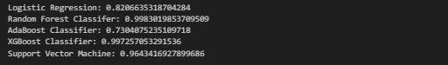

# F1 Score

print(f"Logistic Regression: {f1_score(y_test, y_pred_log)}")

print(f"Random Forest Classifer: {f1_score(y_test, y_pred_random)}")

print(f"AdaBoost Classifier: {f1_score(y_test, y_pred_ada)}")

print(f"XGBoost Classifier: {f1_score(y_test, y_pred_xgb)}")

print(f"Support Vector Machine: {f1_score(y_test, y_pred_svc)}")



# Confusion Matrix

log_reg_cm = confusion_matrix(y_test, y_pred_log)

print(f"Logistic Regression:\n {confusion_matrix(y_test, y_pred_log)}")

random_cm = confusion_matrix(y_test, y_pred_random)

print(f"Random Forest Classifer:\n {confusion_matrix(y_test, y_pred_random)}")

ada_cm = confusion_matrix(y_test, y_pred_ada)

print(f"AdaBoost Classifier:\n {confusion_matrix(y_test, y_pred_ada)}")

xgb_cm = confusion_matrix(y_test, y_pred_xgb)

print(f"XGBoost Classifier:\n {confusion_matrix(y_test, y_pred_xgb)}")

svc_cm = confusion_matrix(y_test, y_pred_svc)

print(f"Support Vector Machine:\n {confusion_matrix(y_test, y_pred_svc)}")

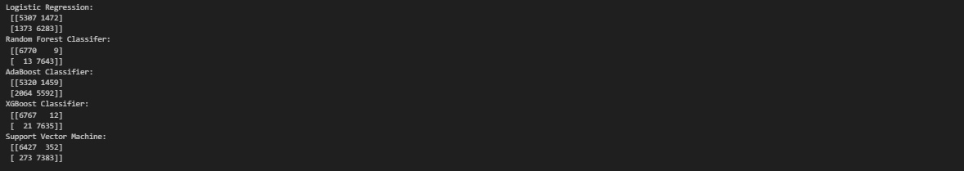

# Visualize the confusion matrix

from sklearn.metrics import ConfusionMatrixDisplay

disp1 = ConfusionMatrixDisplay(

    confusion_matrix=log_reg_cm,

    display_labels= ['T', 'F']

)

disp1.plot(cmap='GnBu')

plt.title("Logistic Regression Confusion Matrix without Normalization")

plt.xlabel("Predicted Label")

plt.ylabel("True Label")

plt.show()

disp2 = ConfusionMatrixDisplay(

    confusion_matrix=random_cm,

    display_labels= ['T', 'F']

)

disp2.plot(cmap='GnBu')

plt.title("Random Forest Confusion Matrix without Normalization")

plt.xlabel("Predicted Label")

plt.ylabel("True Label")

plt.show()

disp3 = ConfusionMatrixDisplay(

    confusion_matrix=ada_cm,

    display_labels= ['T', 'F']

)

disp3.plot(cmap='GnBu')

plt.title("AdaBoost Confusion Matrix without Normalization")

plt.xlabel("Predicted Label")

plt.ylabel("True Label")

plt.show()

disp4 = ConfusionMatrixDisplay(

    confusion_matrix=xgb_cm,

    display_labels= ['T', 'F']

)

disp4.plot(cmap='GnBu')

plt.title("XGBoost Confusion Matrix without Normalization")

plt.xlabel("Predicted Label")

plt.ylabel("True Label")

plt.show()

disp5 = ConfusionMatrixDisplay(

    confusion_matrix=svc_cm,

    display_labels= ['T', 'F']

)

disp5.plot(cmap='GnBu')

plt.title("SVM Confusion Matrix without Normalization")

plt.xlabel("Predicted Label")

plt.ylabel("True Label")

plt.show()

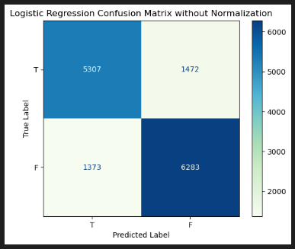

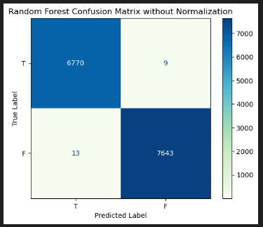

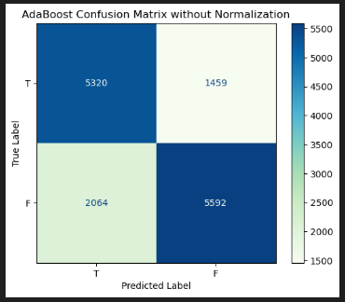

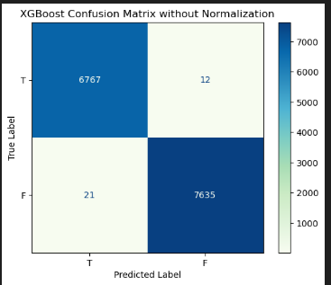

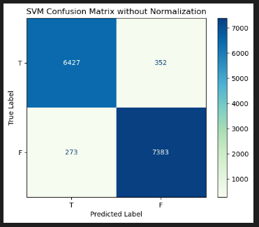

# Normalization of Confusion Matrix (We only show here one normalised confusion matrix, similarly we can show the normalised confusion matrix for other four models)

cm_normalized = cm.astype('float') / cm.sum(axis=1)[:, np.newaxis]

print("Normalized Confusion Matrix")

np.set_printoptions(precision=4, suppress=True)

print(cm_normalized)

disp = ConfusionMatrixDisplay.from_predictions(y_test, y_pred_svc, normalize='true', display_labels=["T", "F"], cmap='GnBu')

disp.ax_.set_title("Normalized Confusion Matrix")

plt.show()



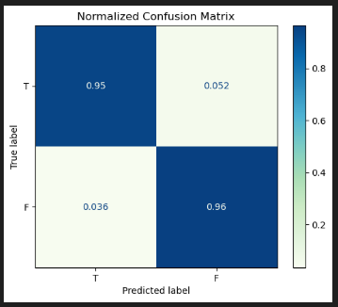

**AUC and ROC for Different Models**

from sklearn.metrics import roc_curve, auc

fpr, tpr, thresholds = roc_curve(y_test, y_pred_svc)

# Compute Area Under the Curve (AUC) using the trapezoidal rule (we only show for SVM model, we can also show for the other four models in the similar way)

roc_auc = auc(fpr, tpr)

print(f"Y: {y_test}")

print(f"Y_HAT: {y_pred_svc}")

print(f"FPR: {fpr}")

print(f"TPR: {tpr}")

print (F"Optimal threshold index: {np.argmax(tpr - fpr)}")

print (F"Optimal threshold value: {thresholds[np.argmax(tpr - fpr)]}")

print(f"AUC: {roc_auc}")

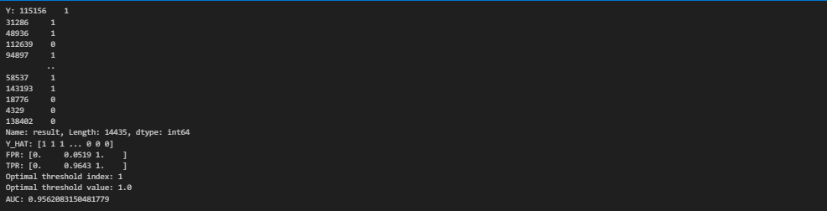

# ROC Curve

plt.figure()

lw = 2

plt.plot(fpr, tpr, color = 'darkorange',

         lw = lw, label = 'ROC curve (area = %0.2f)' % roc_auc)

plt.plot([0, 1], [0, 1], color = 'navy', lw = lw, linestyle = '--')

plt.xlim([0.0, 1.0])

plt.ylim([0.0, 1.05])

plt.xlabel('False Positive Rate')

plt.ylabel('True Positive Rate')

plt.title('Receiver Operating Characteristic')

plt.legend(loc = "lower right")

plt.show()

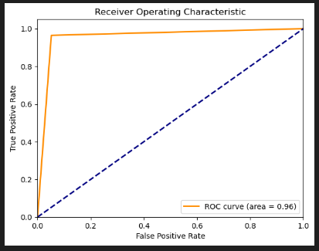

**Test results on Different Models**

print(f"Logistic regression testing: {log_pipe.predict_proba(X_test)[10]}")

print(f"Random Forest testing: {random_pipe.predict_proba(X_test)[10]}")

print(f"AdaBoost testing: {ada_pipe.predict_proba(X_test)[10]}")

print(f"XGBoost testing: {xgb_pipe.predict_proba(X_test)[10]}")

print(f"SVM testing: {svc_pipe.predict_proba(X_test)[10]}")



import pickle

pickle.dump(log_pipe,open('log_pipe.pkl','wb'))

pickle.dump(random_pipe,open('random_pipe.pkl','wb'))

pickle.dump(ada_pipe,open('ada_pipe.pkl','wb'))

pickle.dump(xgb_pipe,open('xgb_pipe.pkl','wb'))

pickle.dump(svc_pipe,open('pipe.pkl','wb'))

**USER INTERFACE BUILDING (app.py)**

**import** streamlit **as** st

**import** pickle

**import** sklearn

**import** pandas **as** pd

**import** plotly**.**express **as** px

teams **=** [

    'Sunrisers Hyderabad'**,**

    'Mumbai Indians'**,**

    'Royal Challengers Bangalore'**,**

    'Kolkata Knight Riders'**,**

    'Punjab Kings'**,**

    'Chennai Super Kings'**,**

    'Rajasthan Royals'**,**

    'Delhi Capitals'

]

cities **=** ['Hyderabad'**,** 'Bangalore'**,** 'Mumbai'**,** 'Indore'**,** 'Kolkata'**,** 'Delhi'**,**

       'Chandigarh'**,** 'Jaipur'**,** 'Chennai'**,** 'Cape Town'**,** 'Port Elizabeth'**,**

       'Durban'**,** 'Centurion'**,** 'East London'**,** 'Johannesburg'**,** 'Kimberley'**,**

       'Bloemfontein'**,** 'Ahmedabad'**,** 'Cuttack'**,** 'Nagpur'**,** 'Dharamsala'**,**

       'Visakhapatnam'**,** 'Pune'**,** 'Raipur'**,** 'Ranchi'**,** 'Abu Dhabi'**,**

       'Sharjah'**,** 'Mohali'**,** 'Bengaluru']

pipe **=** pickle**.**load(open('pipe.pkl'**,**'rb'))

st**.**title('🏏 IPL Win Predictor')

col1**,** col2 **=** st**.**columns(2)

**with** col1**:**

    batting_team **=** st**.**selectbox('Select the batting team'**,**sorted(teams))

team2 **=** [team **for** team **in** teams **if** team **!=** batting_team]

**with** col2**:**

    bowling_team **=** st**.**selectbox('Select the bowling team'**,**sorted(team2))

selected_city **=** st**.**selectbox('Select host city'**,**sorted(cities))

target **=** st**.**number_input("🎯 Target Score"**,** **min_value=**1**,** **max_value=**350**,** **step=**1**,** **format=**"%d")

col3**,**col4**,**col5 **=** st**.**columns(3)

**with** col3**:**

    score **=** st**.**number_input("🏏 Current Score"**,** **min_value=**0**,** **max_value=**target**,** **step=**1**,** **format=**"%d")

**if**( score **>=** target)**:**

        st**.**toast("Score should be less than target"**,** **icon=**"⚠️")

        st**.**stop()

**with** col4**:**

    overs **=** st**.**number_input("⏱ Overs Completed"**,** **min_value=**1**,** **max_value=**20**,** **step=**1**,** **format=**"%d")

**with** col5**:**

    wickets **=** st**.**number_input("🚨 Wickets Fallen"**,** **min_value=**0**,** **max_value=**10**,** **step=**1**,** **format=**"%d")

**if** st**.**button('Predict Probability')**:**

    runs_left **=** target **-** score

    balls_left **=** 120 **-** (overs**\***6)

    wickets **=** 10 **-** wickets

    crr **=** score**/**overs

    rrr **=** (runs_left**\***6)**/**balls_left

    input_df **=** pd**.**DataFrame({'batting_team'**:**[batting_team]**,**'bowling_team'**:**[bowling_team]**,**'city'**:**[selected_city]**,**'runs_left'**:**[runs_left]**,**'balls_left'**:**[balls_left]**,**'wickets'**:**[wickets]**,**'total_runs_x'**:**[target]**,**'crr'**:**[crr]**,**'rrr'**:**[rrr]})

    result **=** pipe**.**predict_proba(input_df)

    loss **=** result[0][0]

    win **=** result[0][1]

    col_result**,** col_chart **=** st**.**columns([1**,** 1.5])

**with** col_result**:**

        st**.**subheader("🔮 Win Probability")

        st**.**write(f"### 🟢 {batting_team}: **{round(win **\*** 100)}%**")

        st**.**write(f"### 🔴 {bowling_team}: **{round(loss **\*** 100)}%**")

**with** col_chart**:**

*# Pie Chart*

        pie_df **=** pd**.**DataFrame({

            'Outcome'**:** [f'{batting_team} Win'**,** f'{bowling_team} Win']**,**

            'Probability'**:** [win**,** loss]

        })

        fig_pie **=** px**.**pie(

            pie_df**,** **values=**'Probability'**,** **names=**'Outcome'**,**

**color_discrete_sequence=**['#00cc96'**,** '#EF553B']**,**

**title=**''**,**

**hole=**0.4

        )

        st**.**plotly_chart(fig_pie**,** **use_container_width=**True)

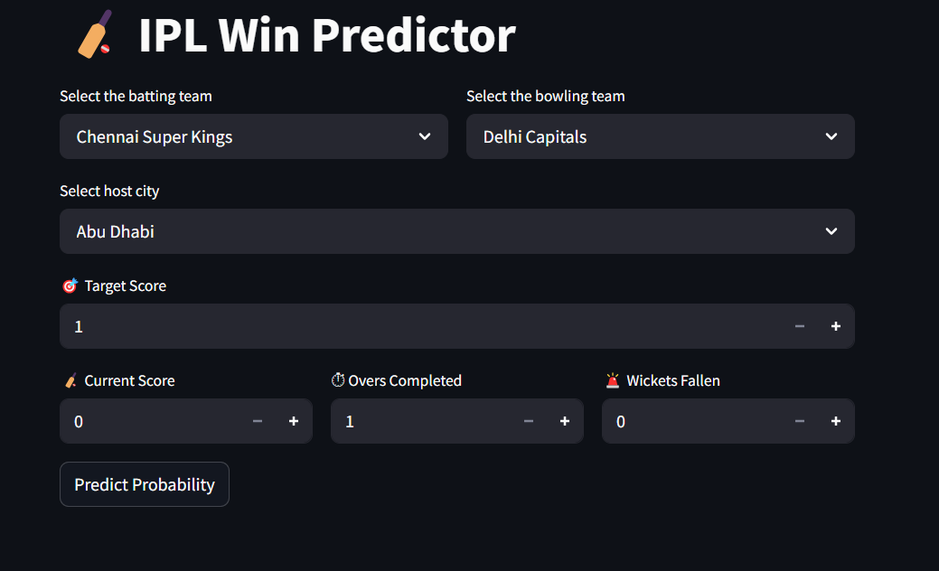



Future Scope of Improvement

While the IPL Win Predictor demonstrates strong potential and delivers accurate predictions based on key match parameters, several enhancements can be made to improve the model's accuracy, usability, and adaptability. Below are possible future improvements and directions for expansion:

### 1. Incorporation of Real-Time Ball-by-Ball Data

Currently, the model predicts outcomes based on summary statistics like runs, overs, and wickets. Integrating real-time ball-by-ball feeds from APIs (such as CricAPI or ESPNcricinfo) could:

* Enable live updating predictions after every ball.
* Incorporate player-specific performance per delivery (e.g., dot balls, boundaries).
* Add predictive trends based on recent overs.

**2. Player Form and Line-up Details**

The model does not currently account for individual player performance, injuries, or recent form. Future versions could include:

* Batter and bowler form (average, strike rate, economy).
* Playing XI impact (star players vs. bench strength).
* Player-vs-player matchup insights.

By adding this layer, predictions would be more dynamic and tailored to real match conditions.

**3. Venue and Pitch Conditions**

Although city information is considered, detailed pitch reports and weather forecasts (e.g., dew factor, pitch type—batting or bowling friendly) could significantly enhance prediction accuracy. These could be fetched using:

* Weather APIs for live updates.
* Historical data per stadium (first/second innings success rate, average score, etc.).

**4. Model Optimization and Alternatives**

Currently, the model uses a machine learning pipeline (likely based on logistic regression or random forest). Future work can explore:

* Advanced ensemble methods like XGBoost or CatBoost for better feature handling.
* Deep learning approaches like RNNs or transformers for sequence modeling of match progression.
* Time-series forecasting methods for predicting match direction over time.

Comparison of model performances (e.g., accuracy, AUC-ROC) could validate the best-fit algorithm.

**5. Interactive Dashboard Enhancements**

The current Streamlit UI is user-friendly and functional, but future iterations can include:

* **Match Timeline Visuals**: A line chart showing how win probabilities change over time.
* **Score Projection Tools**: Predict projected score based on current run rate and batting aggression.
* **Scenario Simulation**: Allow users to simulate "what-if" cases (e.g., "What if Kohli scores 20 runs in the next over?").

These features would make the tool more engaging for analysts and fans.

**6. Multilingual and Mobile-Friendly Versions**

To reach a broader audience across India and globally:

* Offer multilingual UI (e.g., Hindi, Tamil, Bengali).
* Deploy a responsive mobile application version using Flutter or React Native.
* Add voice input for hands-free interaction.

**7. Historical Analysis and Post-Match Review**

The model can be extended to perform:

* Match result retrospectives with prediction accuracy reviews.
* Historical performance trends per team, venue, or captain.
* Use as a training and analysis tool for teams and commentators.

**8. Gamification and Community Features**

To encourage user interaction and retention:

* Users could guess match outcomes and earn points.
* Leaderboards and prediction contests.
* Social sharing of predictions to generate engagement.

# Conclusion

The IPL Win Predictor project demonstrates how machine learning can be applied effectively to the domain of sports analytics, particularly in the fast-paced and dynamic environment of T20 cricket. The central objective of the project was to build a robust model that could predict the winning probability of a team based on match-specific features such as the batting and bowling teams, city, current score, overs completed, wickets fallen, and the target score.

To achieve this, multiple machine learning models were implemented, tested, and compared, including:

* **Logistic Regression**: Used as a baseline due to its interpretability and suitability for binary classification problems like win/loss.
* **Random Forest**: Leveraged for its ensemble nature and ability to capture non-linear relationships in the dataset.
* **AdaBoost (Adaptive Boosting)**: Used to reduce bias and variance by combining multiple weak learners into a strong learner.
* **Extreme Gradient Boosting (XGB)**: Applied for its superior performance in handling structured data and reducing overfitting.
* **Support Vector Machine (SVM)**: Evaluated for its effectiveness in high-dimensional spaces and ability to define optimal decision boundaries.

After training and evaluating these models using performance metrics like accuracy, precision, recall, and ROC-AUC score, the best-performing model was selected and serialized using pickle for deployment in a real-time prediction environment.

The chosen model was integrated into an interactive web application built with **Streamlit** for a clean and responsive front-end interface. **Plotly** was used to provide engaging visualizations, such as dynamic pie charts representing win probabilities. The UI allows users to input live match data and immediately receive predictions, providing a seamless experience for cricket fans, analysts, and enthusiasts.

Although the current model performs well, it operates within the limitations of its feature set and historical data scope. It simplifies the complexity of a cricket match into numerical inputs and does not yet factor in player form, pitch behavior, or real-time external factors such as weather. These simplifications represent opportunities for enhancement rather than shortcomings.

In conclusion, this project not only fulfills its objective of predicting IPL match outcomes but also lays a strong foundation for the application of machine learning in sports. With future improvements like real-time data integration, advanced player analytics, and enhanced modeling techniques, the IPL Win Predictor can evolve into a comprehensive decision-support and engagement tool for the cricketing ecosystem—serving fans, commentators, analysts, and even team strategists.

References

* + <https://www.kaggle.com/datasets>
  + <https://numpy.org/doc/>
  + <https://pandas.pydata.org/>
  + <https://scikit-learn.org/>
  + <https://matplotlib.org/stable/index.html/>
  + <https://seaborn.pydata.org/>
  + <https://bitbucket.org/toarnabtrainer/aec_ml_mca_feb_2025/>
  + <https://docs.streamlit.io/>